Module 7

Information and Communication using Firefox and Novell Evolution

Module Overview
Welcome to Module 7: Information and Communication using Firefox and Novell Evolution. This module has two sections. The first is designed to give you an understanding of some of the concepts and terms associated with using the Internet and basic navigation on the World Wide Web. The second section will cover Internet communications. Internet communications can take many forms: e-mail, blogs, wikis, message boards, newswires, and podcasts to name a few.

 | Upon completion of this module you will:  - Understand the concepts and terms associated with using the Internet.  - Appreciate some of the security considerations.  - Learn how to search and navigate the Web using Firefox browser.  - Gain the ability to bookmark Web sites and print web pages.  - Be able to navigate and complete web-based forms.  - Use the Web for searching and finding information.  - Understand the concepts of electronic mail (e-mail) and appreciate some of the security concerns involved.  - Learn to send and receive messages, and to attach files to e-mail messages.  - Learn to organise and manage messages into mailboxes within the e-mail software Evolution.

 | Terminology
 | TCP/IP | Transmission Control Protocol / Internet Protocol, The protocol that controls communication across the Internet.
 | HTTP | Hypertext Transfer Protocol – the protocol that controls communication across the World Wide Web.
 | Internet Backbone | The main links which join continents, countries and major cities.
 | HTML | Hypertext Markup Language, a markup language that is used to create web pages.
 | FTP | File Transfer Protocol - protocol required for downloading or uploading files over the Internet.
 | World Wide Web | Part of the Internet that supports the viewing of many types of media, including text, images, audio, video and animation.
 | Web Pages | Web pages are files that contain HTML and other types of content that can be viewed using a Web browser.
 | Web Browser | An application that can interpret Web content and make it viewable on a computer. Examples are Internet Explorer, Mozilla Firefox and Opera.
 | URL | Uniform Resource Locator is a unique address on the Internet for Web content.
 | Hyperlink | A link attached to Web content that directs a Web browser to a URL.
 | Cache | Cache is the name given to memory used for speeding up operations. A web browser uses cache to store web pages that you have accessed in the past.
 | Cookies | Small programs transferred onto your computer when you access certain web sites. Cookies store information that is sent back to the web site when you access it.
 | Internet Service Provider | Special types of businesses whose purpose is to provide links for individuals and small organisations to the Internet.
 | Digital Certificates | A digital certificate is an electronic document that proves the authenticity of a web site.
 | Digital Encryption | Digital encryption refers to the scrambling of data so that it cannot be read without a key.


Preknowledge

We recommend you study Module 1: Concepts of Information Technology before starting Module 7. Module 1 will help you become familiar with many different technology concepts. In particular, you will need to know the sections on Information Networks, IT Use in Everyday Life, and Security.

Note: You should have access to the Internet with Firefox and Novell Evolution installed on your system when attempting the activities in this module.

The Internet

Section Overview

This section focuses on The Internet. After studying this section you will understand the concepts and terms related to the Internet, the security issues for consideration and use of the Firefox browser.
By the end of this section you will:

- understand and distinguish between Internet and the World Wide Web
- understand key terms associated with the Internet
- learn what website security entails, what some of the security threats are, and what solutions are available
- be introduced to online transactions.


Concepts/Terms

The Internet consists of all computers and networks across the world which is able to communicate with each other using telephone, fibre optic, microwave, radio, satellite or any other type of link. The Internet includes private, commercial, government and military computer systems.

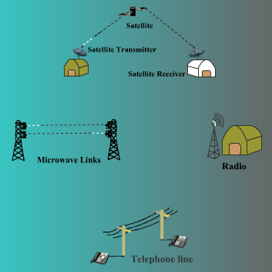

Large networks are interconnected with each other through what is called the Internet Backbone. The main links which join continents, countries and major cities are collectively called the Internet Backbone.

Wikipedia gives a graphical representation of the Internet backbone of the world:

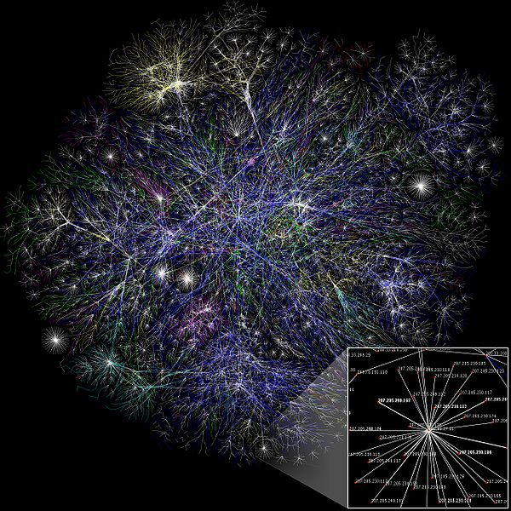
(wikipedia.org/wiki/File:Internet_map_1024.jpg)

Computers on the Internet use specific rules, called protocols that define the procedures for communication. Protocols are programming standards that application developers must follow, and are integral to Internet interoperability. The protocol that controls communication across the Internet is called TCP/IP or Transmission Control Protocol / Internet Protocol.

The World Wide Web, WWW or in short the Web is part of the Internet. What distinguishes the Web is its support of a variety of media, including text, graphics, audio, video, and animation. The Web is a network of servers that store web pages, which can be read by browsers (programmes/applications that are able to read the Web) such as Firefox, Opera or Internet Explorer. Web pages in turn have a specific format known as HTML or Hypertext Markup Language. A browser is an application that is able to read (but not create) web pages.

Key Terms

Protocol

A protocol is a rule for communication. Communication takes places at several levels.

TCP/IP

TCP/IP (Transmission Control Protocol / Internet Protocol) is the protocol that controls the flow of communication. Any specific type of communication that takes place needs additional rules that define how it will take.

HTTP

When HTML pages are transmitted across the Internet, the procedures are defined by another protocol called HTTP or HyperText Transfer Protocol.

FTP

File Transfer Protocol (FTP) is a standard network protocol used to exchange and manipulate files over the Internet.

URL

Each website has a unique address called its URL or Uniform Resource Locator. The URL is also sometimes referred to as a web address. The structure of URLs will be discussed in the next section on page 6. To access a website, you would type its URL into the browser search window and press <Enter> or click the Search button (the green right-facing triangle in the example below).

Hyperlink

Hyperlinks are links attached to text and icons in web pages and documents that enable you to go directly to another places in your document or to other sites without having to type its URL into the search window.

By convention, text which has a hyperlink associated with it is shown in a blue underlined font.

To use a hyperlink, simply click on the text. The browser is able to interpret the hyperlink and locate and display the place/site automatically.

Internet Service Providers

To access the Internet, you need certain things:

- A computer
- A connection to the Web
- Web browser software on your computer
- An account with an Internet Service Provider (ISP).

As an individual, you cannot access the Internet Backbone directly. You need to have a link to an organisation that does. Special types of businesses have arisen whose purpose is to provide links for individuals and small organisations to the Internet. These companies are called Internet Service Providers or ISPs.

In exchange for a fee, they will provide you with a link between your computer and the Internet backbone. ISPs vary in price and quality. Quality in this sense refers to how easy it will be for you to establish a connection and, once connected, how fast that connection will be.

Structure of a Web Address

To find documents on the Web, it must have a unique Web address or a URL. A web address consists of a minimum:
- a protocol
- a server name
- a domain name

Optionally it can have:
- the directory path to a particular web page
- a file name

The simplest form’s full entry will look like the following:
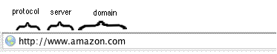

- The first part http:// indicates that the browser is to use the http protocol. It is also possible to access a site where you can download files using FTP. In this case the entry should like this:
ftp://svr5.fileaway.co.za.

You can type a Web address into a Web browser without typing the protocol, if you do the browser assumes http:// and adds that part of the address as a convenience.

The rest of the address has a number of components separated by periods (full stops). Examples include: www.amazon.com, www.yahoo.co.uk, www.absa.co.za, www.icdlafrica.org, mail.sybaweb.co.za

- The first part is the name of the server, www.

- The part of the name following the server name is known as the domain name. Thus in www.amazon.com, the server www is attached to the domain amazon.com.

Just as many people have the same name, so do many servers. In fact, most, though not all, servers on the Internet are called www. However, each combination of server and domain must be unique.

- The final part of the domain name is called the top level domain zone. Some top level zones such as .com, .net and .org are international zones as they do not relate to any country in particular.

Sometimes the top level domain zone corresponds to a country. Some examples are: .uk (United Kingdom), .za (South Africa), .ke (Kenya), .au (Australia), .ca (Canada) and .fr (France).

Most organisations in the United States use the international top level zones .com, .org, .net. There are also some newer ones available such as .biz and .info.

Most countries allocated the next level to specific organisations. For example, in South Africa you have .co.za (commercial organisations), .org.za (not-for profit organisations), .ac.za (academic and research institutions) and .gov.za (government departments).

A web site consists of a number of web pages. A web page is an item which is stored under a particular name on the web site. Often you will be required to enter a specific page to find information. Or you have to follow through a path (see module 2) to get to the page. This is called the directory path. For example:

http://www.mybook.co.za/with/thestars can be analysed as:

http - protocol
www - server
mybook.co.za - domain name
co.za - Top level domain zone telling us it is a commercial website in South Africa
with/thestars - directory path (go to a folder called with and within it you will find a sub-folder thestars and find a file there)

http://www.galactic-info.ac.za

If you enter a URL like this, the web server will direct you to a default page (usually index.htm, index.html, default.htm, default.html).

If, for example, you enter the URL http://www.canada.com, the web server will direct you to http://www.canada.com/index.html.

To review, the browser would interpret the following address as follows:
http://www.wikieducator.org/CCNC/
- Use the HTTP protocol
- Go to the server named www
- It is found attached to the domain wikieducator.org
- It is an international organisation or an organisation based in the USA
- When accessing the web site, it will go to a folder CCNC and it will display the page/file index.html located within the folder CCNC.
If you want to go to another file/page in the folder, you have to type in the name of the file, e.g.:

http://www.ijurnal.ac.uk/issue_14/ij_14_04_articleframe/Petrides_Jimes.html

- Use the HTTP protocol
- Go to the server named www
- It is found attached to the domain ijurnal.ac.uk
- It is an academic institution based in the UK
- When accessing the web site, it will go to a folder issue_14 and a subfolder ij_14_04_articleframe
- In the subfolder it will find the page/file called Petrides_Jimes.html

Web Browsers

A Web browser has a very straight forward purpose, which is to locate files using their URL and display their contents on-screen.

Examples of browsers include Firefox, Internet Explorer, Opera and Netscape.

Although browsers have a very specific purpose, they can have many features which improve their functionality.

These include:
- navigate to and between sites. This is sometimes called surfing the web
- record your visits to sites called the history
- mark important sites called bookmarks
- display options to speed up access. For example, if you have a slow Internet connection browsers can be set to not display graphics. Because graphics typically are large files, the can cause the computer to appear to run very slowly.
- enforce various levels of security and privacy called privacy settings
- prevent the execution of cookies (you set your browser). Cookies are small programs that are downloaded from web sites. Usually they do such things as collect information about your computer or browser, but there have been privacy issues with cookies.
- change the display in various ways

Cookies

Web sites frequently make use of graphics. Web sites may also need to know certain things about your computer or be able to make changes to the way your computer is functioning in order for you to do things on the website. In order to achieve the above, they transfer small programs called cookies onto your computer when you access the site.

Although cookies are often very useful, they do have a negative aspect. They could, for example, contain a virus. Alternatively, they could scan your computer for information such as access codes and passwords, and send these back to their source.

When you allow cookies, you are also exposing your computer to a number of serious risks. Unfortunately, some sites cannot be accessed unless cookies are allowed.

Browsers give some control over cookies. You can set them so that they block all cookies, or allow cookies only from certain trusted sites or allow them all.

If your browser is set to allow all cookies, it’s important that you follow some basic rules of safe computing:
- visit only trusted web sites
- have good virus protection software that is updated daily

Cache

Because web sites often contain a lot of graphics, they can take considerable time to load. To speed up the process of accessing web sites, your browser can make use of a cache.

Cache is the name given to memory used for speeding up operations. A web browser uses cache to store web pages that you have accessed in the past. If you call up the same page, instead of loading it across the Internet, it retrieves it from cache.

There are programs called web accelerators that speed up the operation of browsers. Accelerators make use of cache in a different way. They anticipate the web sites you are likely to use based on the sites you have been accessing. While you are working on a site, the accelerator will load these sites into cache ready for immediate use.

Security

Web Site Security

Most web sites are unprotected. This means anyone can access them and read their contents.

Some sites are protected. As soon as you attempt to access them, a dialogue box will appear on-screen asking for a user id and password. Unless you can supply these, you will not be able to progress further.

Some sites have a mixture of protected and unprotected areas.

The registration processes required to access protected sites vary. Examples are:
- paying a fee
- on joining an organisation, you may receive a user name and password which allows you access to protected areas of a web site
- completing a questionnaire in which you give personal details. Once this has been done, a user name and password is e-mailed to you
- entering a verification code which is a randomly machine generated code displayed as an image so only a human being could read the image and type the number and not a machine. This prohibits machines accessing personal information.
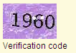

Banks have more layers of website security, especially when using Internet banking:
- They make use of access numbers and PIN numbers that must be entered by using an on-screen numerical pad. This makes it impossible for a machine to grab your pin number. Furthermore they can also ask you to enter only certain digits of your password. This is to ensure that not all your logon information is displayed, to help combat Identity fraud.
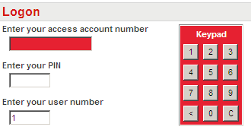
Password

- Random Verification Number (RVN)
In order to execute PrePaid purchases, create a beneficiary, stop payment or operator on Internet Banking, you have the option to receive a unique code (Random Verification Number) via e-mail or SMS. This Random Verification Number allows you to control PrePaid purchases, the creation of a valid beneficiary, stop order or operator. On entering this number you can proceed with the transaction.
- Time out
If you have logged on and have not used the website for a set number of minutes, you will be logged off. To access your accounts again you will need to LOGON.

Digital Certificates

A digital certificate is the equivalent of positive identification, such as a driver's license. Issued by various certificate authorities, digital certificates are used to prove that a web site, or a visitor to a web site, is the entity or person they claim to be. When sending an e-mail the digital certificate proves the identity of the sender.

A digital certificate is a password protected file that includes the following information:
- the name and e-mail address of the certificate holder
- an encryption key that can be used to verify the digital signature of the holder
- the name of the company issuing the certificate
- the period during which the certificate is valid
The certification authority links a public key to the name in the certificate (Public and private keys will be discussed in the next section).

Digital certificates are used when secure connections need to be established between a computer and a web site. If the digital certificate cannot be verified, the web browser will send a warning message to the user.
The way digital certificates work is explained in the next section on encryption.

A digital signature is an added level of security. Digital signatures have in-built mechanisms that enable recipients to verify that the sender is who he/she says and that information has not been forged. Digital signatures are described more fully in the section called “Know what a digital signature is”.

Sites using these security methods have an address that begins https rather than http. Hypertext Transfer Protocol Secure (HTTPS) is a combination of the Hypertext Transfer Protocol with the SSL/TLS protocol to provide encryption and secure identification of the server.

Digital Encryption

Digital encryption refers to the scrambling of data so that it cannot be read without a key. This means that sensitive and confidential information can be sent across the Internet without being able to be read. The little lock in your browser appears.

For example, if you are doing banking over the Internet, a secure link called SSL (Secure Sockets Layer) is set up between your computer and the server. This involves scrambling the data so that, if it is intercepted, it appears as a meaningless set of characters. Nowadays banks are switching to TSL (Transport Layer Security) which is a higher order security layer as SSL

Encryption involves the use of private keys and public keys. The public key enables the data to be encrypted by anyone. Once it is encrypted, it can only be deciphered with a private key. Only the owner of the site has this.

When a site sends you a digital certificate, they are also sending you a public key which enables you to encrypt information which only it can read.

You May Ask the Question: When is a Website Secure?
Traditionally when you hear someone say 'Our website is Secure' they imply that their website uses SSL (Secure Sockets Layer) and that the traffic is encrypted (The little lock in your browser usually appears).
It is good to have the “best practices” checklist approach. Check for the following:
- Login pages should be encrypted.
- Data validation should be done at the server-side and do not accept client-side data validation.
- The Web site must be managed through encrypted connections. Unencrypted FTP or HTTP opens you up to attacks and login/password sniffing.
- Use strong, cross-platform compatible encryption: SSL is not the top-of-the-line technology for Web site encryption any longer. Look into TLS, which stands for Transport Layer Security — the successor to Secure Socket Layer encryption.
- Connect from a secured network: Avoid connecting from networks with unknown or uncertain security characteristics or from those with known poor security such as open wireless access points in coffee shops. This is especially important whenever you must log in to the server or Web site for administrative purposes or otherwise access secure resources.
- Don’t share login credentials.
- Prefer key-based authentication over password authentication: Password authentication is more easily cracked than cryptographic key-based authentication.
- Maintain a secure workstation.
(From:http://blogs.techrepublic.com.com/security/?p=424)

Internet Fraud and the Use of Credit Cards

Be aware of the possibility of being subject to fraud when using a credit card on the Internet

In order to make use of some sites or order goods or services across the Internet, you will need to pay by credit card. When you give credit card information without the merchant actually seeing the card, it is referred to as a Card Not Present or CNP transaction. There are a number of dangers to both the buyer and the seller.

Vendors need to be sure that the card is not being used fraudulently.

Clients need to be sure that:

- they can afford the goods they are buying. It is very easy to spend money using a credit card on the Internet
- the vendor will not abuse the information and make unauthorised debits. They should not deal with any unknown sites
- the vendor ensures the client that credit card information is not being kept
- the information will not be stolen by employees and used fraudulently. Once again, well known reputable sites will have measures in place and will generally take responsibility if anything does go wrong
- the information will not be stolen and used by hackers. Only use sites that are able to encrypt the information you send using a secure link such as SSL

Firewalls

A firewall is the first line of defence against hackers. It is a computer program that is installed on a computer that connects to the Internet. The firewall software analyses the packets (small groups of data that are transmitted as a unit) that pass between the computer and the Internet. It is programmed to follow certain rules which enable it to decide whether or not to allow a packet to pass. If a packet does not meet the rules programmed into the firewall software, it is rejected.

Virus Infection from a Downloaded File

The Internet is a wonderful source of information and software. Since there is virtually no control exercised over the Internet, it is also a source of danger and even criminal activity.

There are thousands of download sites where you can obtain software and other files, some of it legal some pirated.

Whether or not the software or file is legal, there is always the possibility of viruses being contained in the software or downloaded files. This could be done deliberately by the developer of the site or because it was not checked adequately before being made available.

Remember, viruses can also be transferred in files.

Before downloading software or a file from the Internet, be sure that you can trust the site you are dealing with. There are excellent and safe download sites such as www.tucows.com so you should not need to use dubious sites.

Have excellent virus protection on your computer that you are updating on a regular basis. Run full virus scan regularly on your computer.

Know your Viruses - Malware
The first term that is used for is software designed to infiltrate a computer without the owner's informed consent is Malware, short for malicious software. It is a general term used for a variety of forms of hostile, intrusive, or annoying software or program code.
Malware includes computer viruses, worms, trojan horses, spyware and other malicious and unwanted software.
Software is considered malware based on the perceived intent of the creator rather than any particular features.
Malware was first written as experiments or pranks generally intended to be harmless or merely annoying rather than to cause serious damage to computers. Examples are the first Internet Worm and the Melissa virus.
Later programs were designed to cause harm or data loss. Many DOS viruses, and the Windows ExploreZip worm, were designed to destroy files on a hard disk, or to corrupt the file system by writing invalid data.
However, since the rise of widespread broadband Internet access, malicious software has come to be designed for a profit motive on the black-market.

Infectious Malware: Viruses and Worms

Computer Virus
A computer virus is a computer program that can copy itself and infect a computer without the permission or knowledge of the owner. It infects some executable software and causes that software, when run, to spread the virus to other executable software. It literary insert itself into other programs.
How do you get rid of a virus? – If your antivirus software detects a virus, that file should be cleaned.

Worms
A worm is a program which actively transmits itself over a network to infect other computers. It exploited security holes in network server programs and started itself running as a separate process.
How to get rid of a worm? - If your antivirus software detects a worm there is no legitimate file involved and action should be to delete the file.

Concealed/Camouflaged Malware: Trojan horses

A Trojan horse is a computer program which carries out malicious operations without the user's knowledge.

It is a hidden program which secretly runs commands, and usually opens up access to the computer running it by opening a backdoor (think of the Greek legend). Through this backdoor, hackers can get access to your computer and gain control of it.

Unlike viruses, a Trojan does not replicate (i.e. infect other files), nor does it make copies of itself as worms do.

A Trojan horse may, for example:

- steal passwords
- break security
- copy sensitive data
- carry out any other harmful operations

How do you project your computer from a Trojan? - Installing a firewall (a program which filters data entering and leaving your machine).
How to get rid of a Trojan? - If your antivirus software detects a Trojan there is no legitimate file involved and action should be to delete the file.

Spyware

Spyware is a type of malware that is installed on computers and that collects information about users without their knowledge.

You have to run anti-spyware software to protect your computer form infection.

Spyware does not usually self-replicate like viruses and worms. It includes the delivery of unsolicited pop-up advertisements, theft of personal information, monitoring of web-browsing activity for marketing purposes and routing of http request to advertising sites.

Anti-Virus Software

Anti-virus software contains tools that scan for known viruses and take action to disarm and/or remove them. Because viruses are developed daily, the anti-virus industry has grown and release updates regularly.

They are looking constantly for new occurrences of malware and write programs to disarm or remove them.

It is therefore important to apply:

- prevention – not to download files or open e-mails from unknown or suspicious sources
- protection – have a good and trustworthy anti-virus software installed on your system and update it regularly
- cure – run your anti-virus software regularly, at least once a day

e-Safety

Read the article on the next page and think about the role of parents to safeguard their children on the web.

This includes, but is not limited to supervision, web-browsing restrictions, computer games restrictions and computer usage time limits.

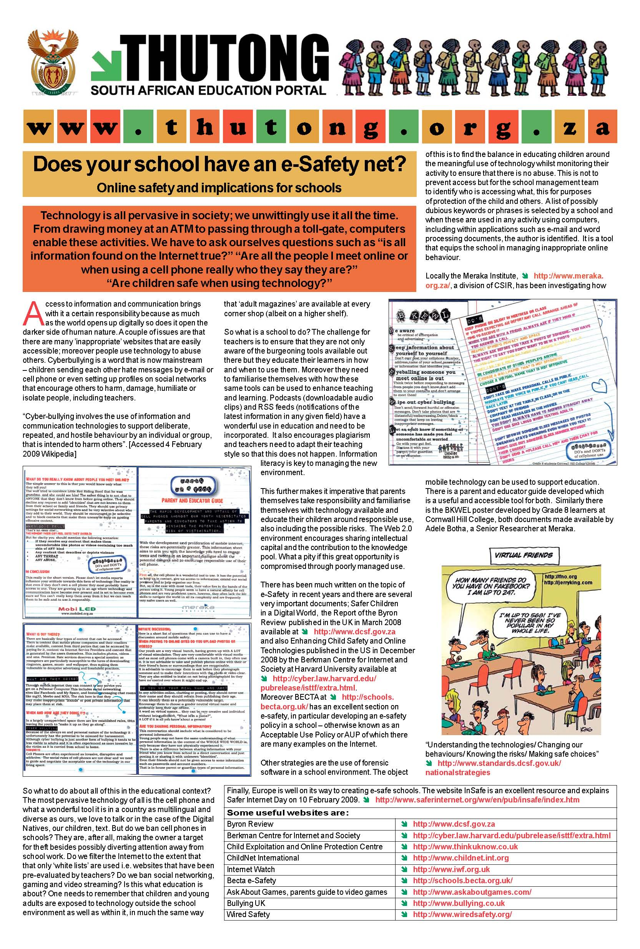


Summary

In this section, we discussed what the Internet is and distinguished between the Internet and the World Wide Web. You were introduced to many Internet technical terms.

We also discussed what is involved in Website security, and some of the technologies that are available to enhance your security on the Web.

Through this section you must instill good security habits when using your own computer or using a computer for your private activities such as banking, buying over the Internet and registering for certain sites and giving your personal information.
Always take care when using public computers (Internet cafes) and unsecure networks.

Using a Web Browser

Section Overview

After studying this section you will be familiar with the features of the Mozilla Firefox Web browser, an application included with Ubuntu that is used for browsing content on the World Wide Web.

In this section you will:
- do basic tasks in Firefox (opening, closing a web browser)
- customise the Firefox window
- learn basic techniques for browsing web pages
- become familiar with Firefox Help features


Opening and Closing a Web Browser

Ubuntu is installed with a web browser already in place: Mozilla Firefox. Firefox is a full-featured Web browser that is the second-most installed browser world-wide (after Microsoft’s Internet Explorer).

Opening Firefox

- Choose ApplicationsInternetFirefox Web Browser from the Ubuntu menu or click on the “Web” icon.

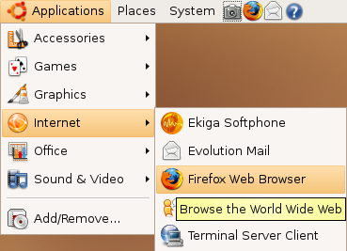 or 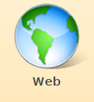

Close Firefox

- Choose File Quit from the Firefox menu

or
- click the Close button in the upper right corner

First Introduction to the Firefox Window
Title Bar
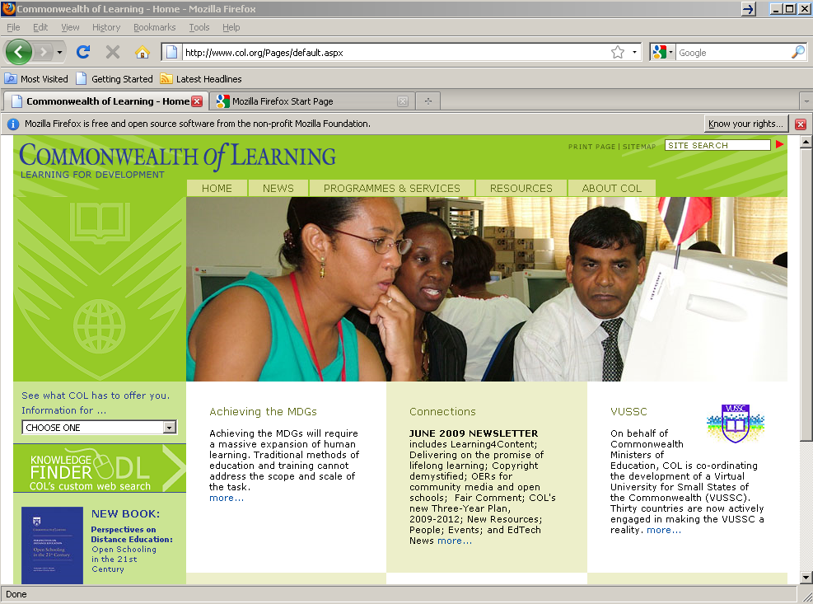
Stop Button
Home Button
Work space
Menu Bar
Address Bar
Reload Button
Back/Forward Buttons

Using the Sidebar
The Sidebar is an area on the left side of the screen that you can use for viewing bookmarks or history. Extensions may add new ways to use the Sidebar as well.
To view an item in the Sidebar, select View Sidebar. From there you can select the Sidebar tab you want.
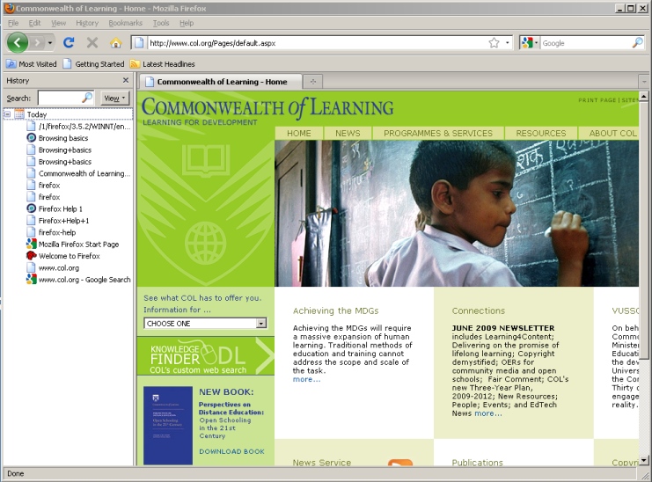
Sidebar activated

Setting up a Home Page or Start Page

There are several ways to set your home page:

The Home Page is the web site that is located and displayed by Firefox when it is loaded by the user. This is set in the Firefox Preferences as follows:
- Choose EditPreferences from the Firefox menu.
- Under the MAIN category (click on Main Tab), there is a section titled "Startup".
- Under Where Firefox starts: you will find a drop-down menu (click to open it) with three options:

- If you choose Show my home page as your option you will need to type in that location.

Your Home Page may be any page you select, a personal site, an educational site, or perhaps a commercial site.

In this example, the Home Page is set to go to Penn State University at http://www.psu.edu (it was typed in).
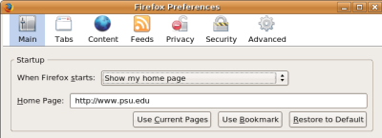
- If you choose Show a blank page Firefox will load a blank page upon opening.
- If you choose Show my windows and tabs from last time Firefox will remember any windows and tabs open from the last instance and display them.

- You can also select one of the three buttons:

- Use current pages – use the active page in your browser
- Use bookmark – let you choose from your saved bookmarks
- Restore to Default – restore the settings to the machine settings

Display a Web Page in a New Window

To display a web page you need to know its URL (web address). The following example illustrates how to access the Google web site. Its URL is http://www.google.com

- Type www.google.com into the Address bar as shown on the next screen and press Enter or click on the green arrow on the right of the Address bar.

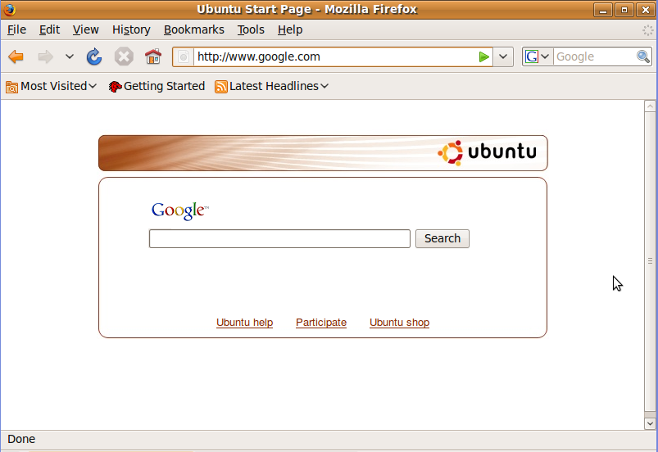

Unsure of URLs

Firefox can make suggestions on the URL you require. For example, if you want to view the web site of CNN but you are unsure of the URL, you could type in CNN in the address bar.

Firefox would attempt to find the site for you and would try various possibilities starting with www.cnn.com.

Opening a New Window

You have been able to open more than one document in other programmes. You can also open more than one site in Firefox and work on more than one site simultaneously.

You can do it in one of two ways, either by opening a new window or by opening a new tab.

Open a New Browser Window

You have already one website open and want to open a second one.

Without closing the first window:

- Choose FileNew Window from the Firefox menu.
- Type the second URL into the Address window.
- Press Enter.

A new window will open displaying the second website. Click on the appropriate icon at the bottom of the screen to switch between the web sites.

Tabbed Browsing

Tabbed browsing is a very good habit to learn. It lets you open multiple tabs, each displaying a web page, within a single Firefox window. It has the advantage of diminishing the screen clutter of having many windows open.

You have to create and load tabs. To open a new tab, press Ctrl+t, or select FileNew Tab.

You open a new page on a new tab and enter the URL.

The different tabs appear at the top of the Working space. You can click on the tab you want to work with.

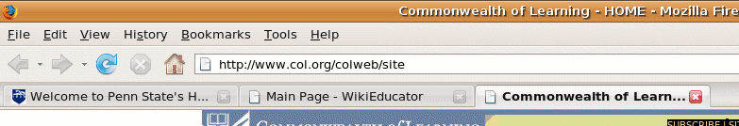

Tip: You can open links in new tabs, where they will load while you read the current page.

Stop a Web Page from Downloading

Web sites often take a while to download, especially if they contain a lot of graphics or if the Internet is very busy at the time you are using it. You can decide to stop a website for downloading and go to another activity.
To stop a web page form downloading click the Stop button  next to the Address bar.

Refresh a Web Page

In order to speed up your computer when working with web sites, Firefox stores copies of pages in a cache or temporary memory area so that they can be recalled more quickly than if they had to be reloaded across the Internet. You can get the most up-to-date version of the page by using the Reload function.
Click the Reload button next to the Address bar (on the left) or press Ctrl+R.

Use Available Help Functions

Firefox comes with an extensive help system. Learning to use the help system can help you become familiar with the full range of the application's functionality.

To access Help, choose HelpHelp Contents from the Firefox menu.

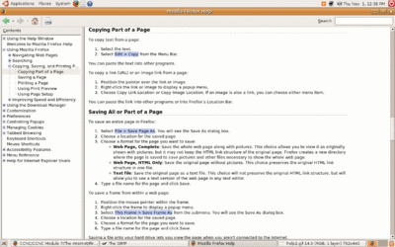

Suppose you wish to find out how to copy a web page.

- Expand Using Mozilla Firefox by clicking the symbol to the left (see the red arrow).
- Expand Copying, Saving and Printing.
- Double click on Copying Part of a Page.

Search the Help Function

The Help Contents are useful if you know exactly what topic you are looking for. It may happen that you are looking for all entries containing a particular key word.

The following example illustrates how to find all help entries that contain the word ‘cache’.

- Choose Help Help Contents from the Firefox menu.
- In the Search look-in space to the top-right of the screen, enter the word cache.

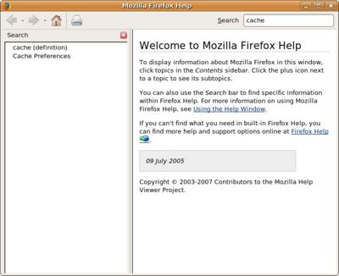

- The topics containing ‘cache’ will appear in the look-in space to the left.
- Click on the entry you wish to view.

Use the Glossary

The glossary is a dictionary of meanings of terms associated with Firefox.
These are listed in alphabetical order.

Click on cache (definition) or any other term’s definition. A glossary of terms will be displayed in the right side window. Scroll and click the term whose meaning you wish to know.

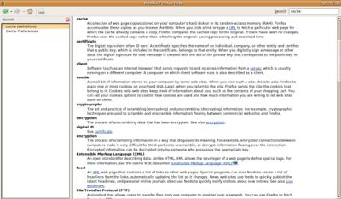

Adjusting Browser Settings

Know more about the Components of the Firefox Interface

On page 19 you have been introduced to the basic terminology of the Firefox window. Before explaining how to show and hide toolbars, it would be useful to become more acquainted with the different components of the Firefox window. These are illustrated on the following screen.
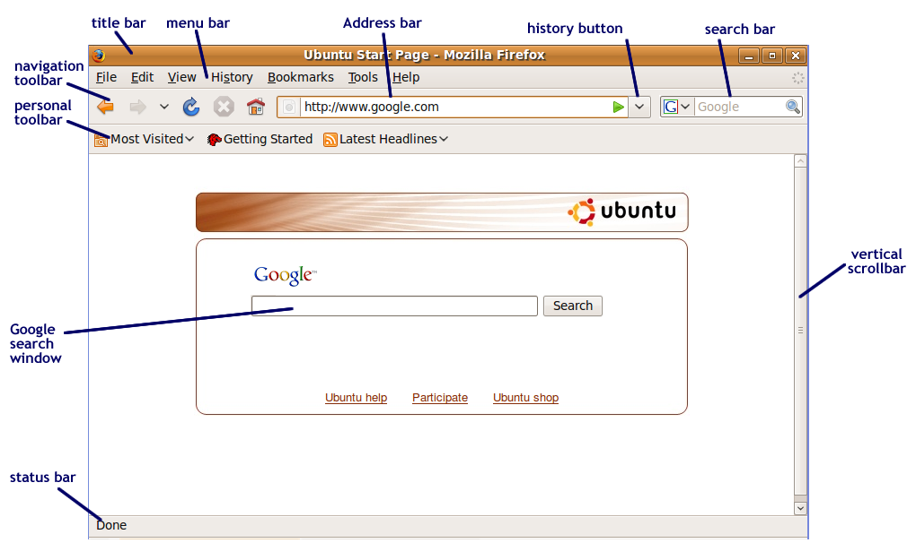

Display, Hide Built-in Toolbars

You can modify the Firefox window by hiding or displaying toolbars. Hiding a toolbar that you don’t use often gives your browser window more room to display web pages.

To show or hide toolbars:

- Choose ViewToolbars from the Firefox menu.
- Uncheck the box to the left of the toolbar to hide it, or check the box to show the toolbar.

Set display to Full Screen Mode

Full screen mode allows you to use the entire screen for the display of web pages. The Navigation bar will be displayed at the top of the screen when you place your mouse at the top of the screen, otherwise it will automatically hide. The rest of the screen is used for the display of the web page.

- Choose ViewFull Screen from the Firefox menu, or press <F11>.
- Press <F11> again to return to normal view mode.

Display, Hide Built-in Web Page

The loading of graphic images when accessing a website can slow down the display of websites very drastically, especially if they are graphic intensive. Often these images are of little use when the user is after information. One way of speeding up access is to suppress the display of images:

- Choose EditPreferences from the Firefox menu.
- Click on the Content tab.
- Uncheck Load Images Automatically.
- Click Close.

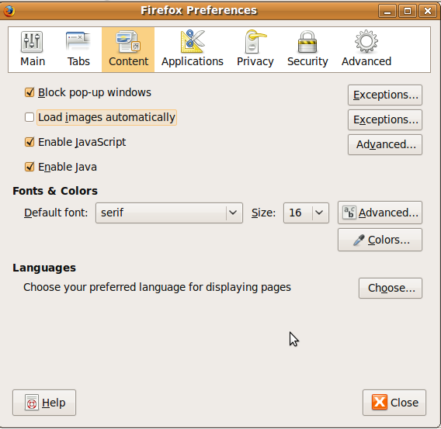

Summary

This section introduced you to the Firefox browser and browsing pages on the Web. You learned how to set up Firefox and how to access the Help features in the application.

Web Navigation

Section Overview

After studying this section you will be familiar with accessing web pages with the Firefox browser, navigating through the Web. You will also learn techniques, such as bookmarking, that will make it easier for you to keep track of the vast amount of information available to you on the Web.
In this section you will:
- understand what a hyperlink is
- learn how to access web pages
- become familiar with navigating the Web.
- learn how to manage your browsing history
- learn how to bookmark pages so they can be easily located and how to manage bookmarks

Accessing Web Pages

Activate a Hyperlink/ Image Link

A hyperlink is a cross-reference to another web site. The hyperlink is attached to an icon or a phrase. When a user clicks on a hyperlink, the browser displays the cross-referenced site. It is possible to do this in the current window or in a new window.

When hyperlinks are attached to phrases, the phrases are usually displayed in underlined blue text e.g. www.col.org. In any case, your mouse cursor will change to a hand when you move your mouse over a hyperlink.

Display the URL of a Hyperlink

The following screen contains a number of hyperlinks at the top of the page:

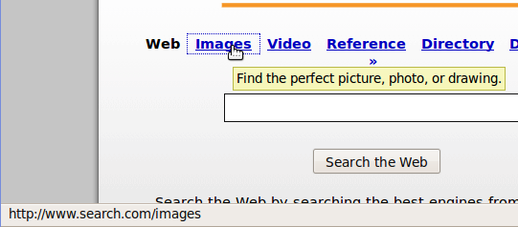

The underlined headings in blue text all represent hyperlinks. The URL of the hyperlink is displayed on the bottom of your browser window, in the status bar. In the image above, the URL of the hyperlink is http://www.search.com/images.

Navigate to the Home Page

You can navigate immediately to the Home Page (see page 20) by clicking on the Home button - .

History

Firefox keeps track of the web pages you have viewed in your current session and longer. This is called History.

You have control over what is saved in your browser history, and you can clear the history whenever you like.

Using the browser history can be a great way to navigate to pages that you’ve visited recently.

Using the Navigation Toolbar

The easiest way to move back and forth through the web pages you’ve visited in a session is to use the back and forward buttons on the Navigation Toolbar.

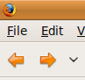

Display Previously Visited URLs

When you access a web site, Firefox records this in its History. You can have access to the list of previously visited URLs by using the address bar.

- Click on the drop down arrow at the right hand side of the browser address bar. A list of recently visited sites is displayed.
- Click the site you wish to visit.

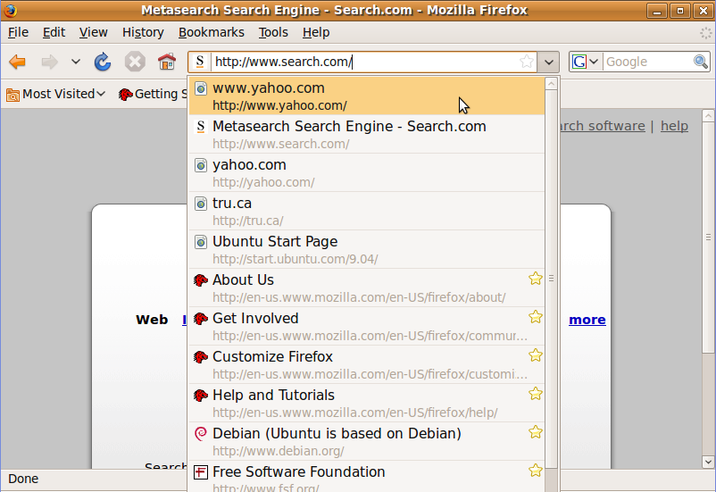

An alternative is to use the Menu bar. The History menu item will display sites visited.

- Choose History from the Firefox menu.

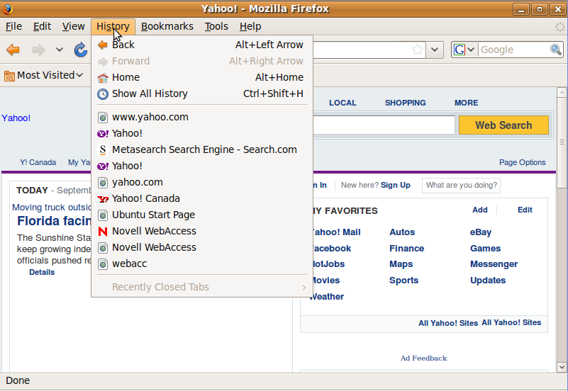

- A list of recently visited sites is displayed at the bottom of the menu.
- Click on the site you wish to visit.

Show All History

You can view the recent browser history by clicking on the History menu. To view all of your browser history:

  - Choose HistoryShow All History from the Firefox menu.

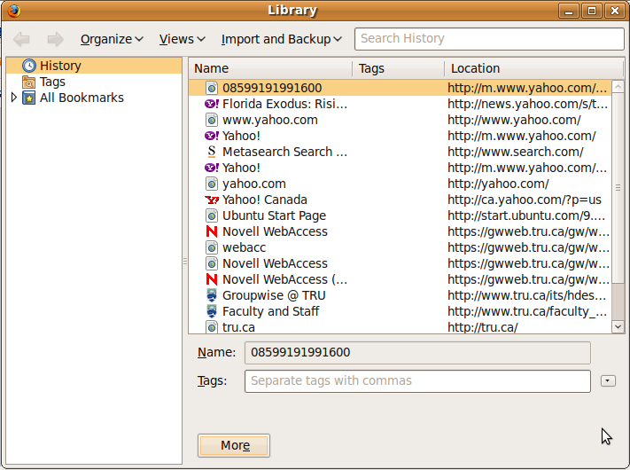

  - Scroll through the history list. You can sort the list by Name, Tags, or Location.

Delete Browsing History

- Choose HistoryShow All History from the Firefox Menu.
- Select the history item(s) you would like to delete.
- Press the <Delete> key on your keyboard.

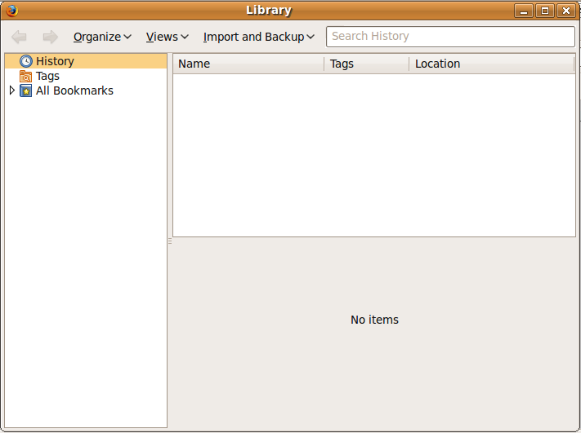

- To delete your entire browsing history, select all entries (you can press the <Ctrl> key and <A> key at the same time to do this) and then press the <Delete> key.

Clear Private Data

Your browsing history is just one part of the data that is saved on your computer. Other files, such as cookies, web pages saved in your browser cache and other data are also saved on your computer.
IT IS IMPORTANT TO CLEAR PRIVATE DATA AFTER EACH SESSION WHEN USING A PUBLIC COMPUTER.

To clear your private data:

    - Choose ToolsClear Private Data from the Firefox menu.
    - Check the items you want to clear.
    - Click the Clear Private Data Now button.

Pop-ups
A pop-up is a small window that appears automatically on top of the website you're viewing without your permission. Pop-up windows often open as soon as you visit a website and are usually created by advertisers.
Pop-ups are normally associated with security risks (check spyware in the first section).
Firefox allows you to control pop-up and is normally referred to as a pop-up blocker. A pop-up blocker is a feature that lets you limit or block most pop-ups. You can choose the level of blocking you prefer, from blocking all pop-up windows to allowing the pop-ups that you want to see. When Pop-up Blocker is turned on, you will get an Information bar message saying "Pop-up blocked. To see this pop-up or additional options click here."
Pop-up blocking is turned on by default.
You can edit pop-up blocker preferences by:
- Choosing EditPreferences.
- Click on the Connect Tab.
- Go to Block pop-up windows: Unselect this preference to disable the pop-up blocker.
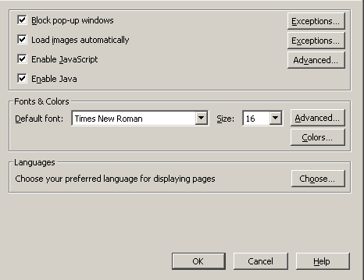
- If you click on the Exceptions button to the right, the Allowed Sites Pop Up dialogue box appears.
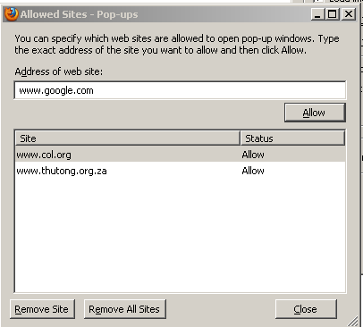
Here you can choose between:
  - Allow – you can add a website to the list to accept pop-ups from.
  - Remove site – remove a marked website from the list.
  - Remove all sites – will remove all of the sites in the exception list.

Cookies

A cookie is a small file stored on your computer by a website you visit. Cookies often store your settings for a website, such as your preferred language or location. When you return to the site, Firefox sends back the cookies that belong to the site. This allows the site to present you with information customised to fit your needs.
Cookies can store a wide range of information, including personally identifiable information (such as your name, home address, e-mail address, or telephone number). However, this information can only be stored if you provide it - websites cannot gain access to information you didn't provide to them, and they can't access other files on your computer.
By default, the activities of storing and sending cookies are invisible to you. However, you can change you Firefox settings to allow you to approve or deny cookie storage requests, delete stored cookies automatically when you close Firefox, and more.
Cookies are enabled by default in Firefox. To check your settings:
- Choosing EditPreferences
- Click on the Privacy Tab.
- Go to Accept cookies from site: Unselect this preference to not accept cookies.
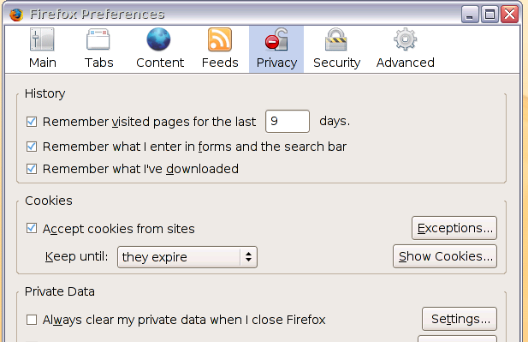
- If you click on the Exceptions button to the right, a dialogue box appears with sites that cannot store cookies on your computer.

- You can also see the cookies that are stored on your computer, by clicking on the Show Cookies button. You can also mark and hit Remove Cookie or click on the Remove All Cookies button to clear the list.
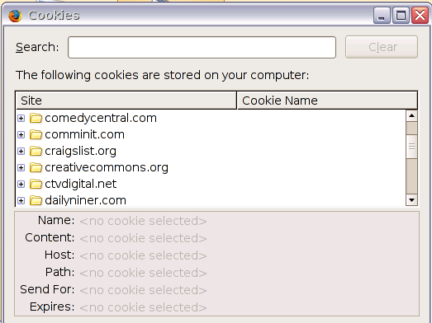

Complete a Web-Based Transaction

Many web pages involve a transaction such as purchasing goods, registering for a course or creating a web based e-mail account. Some of these involve a single form while others involve several forms and could include giving credit card information.

Note: Only supply credit card information over the Internet if you are sure of the web site that you are using and if the site uses a secure method of transferring the information.

In many cases, although the entire process is electronic, it nevertheless represents a contract between yourself and the company or organisation. Many websites such as WikiEducator offer free registrations based on the user agreeing to certain conditions. Clicking an I Agree button is typical of transactions that involve conditions. Only click this button if you agree to the conditions.

Bookmarks

You can store URLs to use it at a later stage. A bookmark is the URL of a site that is stored by Firefox either in the Personal toolbar or in the Bookmarks menu. To access a site that has been bookmarked, you open your bookmarks and click on the name of the web site in the toolbar or menu.

Bookmark a Web page in the Bookmark Menu

If you want to bookmark the WikiEducator web page:

- Access the site by typing http://www.wikieducator.org into the Address bar and press <Enter>.
- When the page is displayed, select BookmarksBookmark This Page or press <Ctrl><D> on your keyboard.

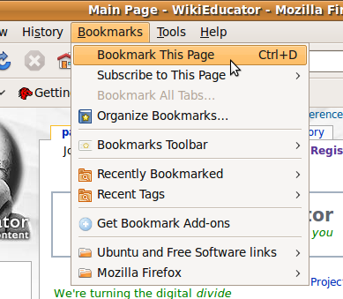

Display a Bookmarked Web Page

To display saved bookmarks:

- Choose Bookmarks Organize Bookmarks.

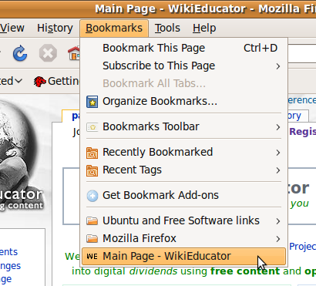

- The Bookmarks Manager/Library dialogue box appears with a list of all bookmarks:

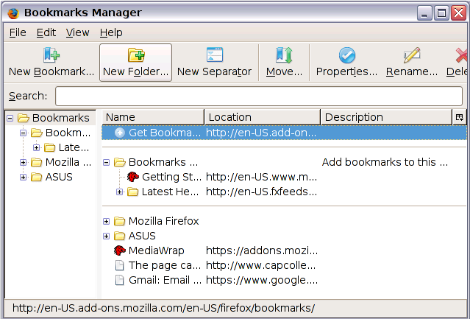

Organising Bookmarks

As the number of bookmarks increases, so does the need for a system for organising them. You can organise your bookmarks in folders, move them from one location to another and delete them by displaying your bookmarks (see above).

Create a Bookmark Folder

The best way of organising your bookmarks, is to create a number of folders. Each folder should be a repository for web pages having something in common. The name of the folder should reflect this.
Firefox has a special dialogue for managing bookmarks.

- Choose BookmarksOrganize Bookmarks from the Firefox menu. This displays the Bookmarks Manager/Library dialogue window.

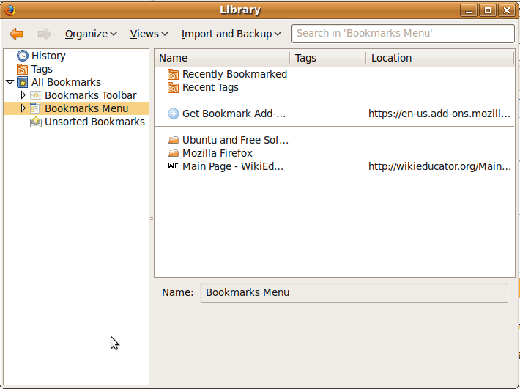

- Choose OrganizeNew Folder or click on the New Folder tab.

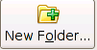
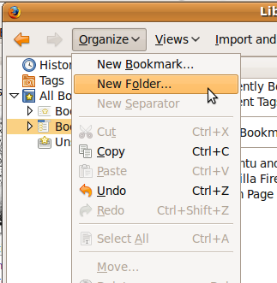 OR

- Complete the details as follow:

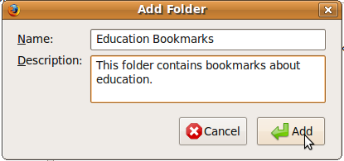
New Name

- Click the Add Button/OK Button.

The new folder will be added to the set of existing folders. You can then organise your existing bookmarks by dragging them into the appropriate folder.

Add Web Pages to a Bookmark Folder

Once you have created folders to organise your bookmarks, you can bookmark pages directly into these folders.

- Locate the web site you wish to bookmark. For example, the Open University of the UK has been accessed at http://www.open.ac.uk/.
- Choose BookmarksBookmark this Page from the Firefox menu.
- Select the folder in which you wish to place the bookmark.

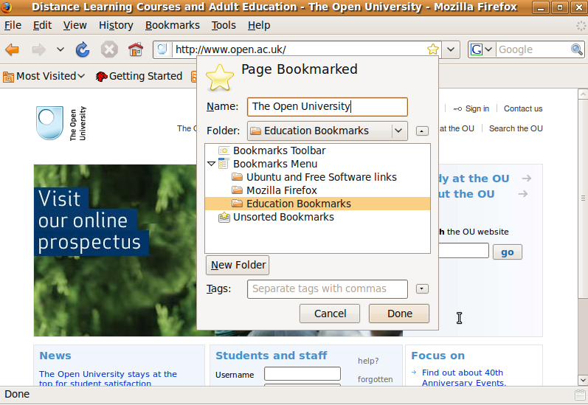

- Click Done.

Delete a Bookmark

To delete a bookmark:
- Choose BookmarksOrganize Bookmarks from the Firefox menu.
- Navigate to the folder that contains the bookmark you wish to delete.
- Select the bookmark by clicking on it.
- Press the <Delete> key.

Delete a Folder and Its Contents

To delete a complete folder with the contents (all the bookmarks in the deleted folder will also be deleted):

- Choose BookmarksOrganize Bookmarks from the Firefox menu.
- Select the folder by clicking on it.
- Press the <Delete> key.

Summary

This section discussed the basics of navigating on the Web with Firefox. We learned about the files that are created when you browse the Web, such as history files, cookies, and cache, and how to manage those files. Finally, you learned how to create and manage bookmarks to help you mange the content you access with your Web browsing.

Web Searching

Section Overview

After studying this section you will be familiar with doing sophisticated searches on the Web to help you find the information you want from the vast quantity of information available.

You will also learn how to capture and save Web content to your computer, and some of the issues related to re-using Web content.
In this section you will:
- be introduced to the Google search engine
- carry out searches based on keywords, language, date and other criteria
- learn how to download text, images, and other files from the Web
- learn how to print a web page

Using a Search Engine

Select a Specific Search Engine

It will frequently happen that you want to look up information on the Internet but do not know where to look. In such a case you can make use of a Search engine.

Search engines, include web search engines, selection-based search engines, meta-search engines, desktop search tools, and web portals and vertical market websites that have a search facility for online databases.

For the purpose of this course, we define a search engine as a web site that will find the locations of web sites for you which contain key words or phrases. There are a number of these available. Go to Wikipedia: http://en.wikipedia.org/wiki/List_of_search_engines
to see a list of search engines.

The three most popular search engines are Google, Bing and Yahoo. Google is the most popular, because of the relevance and accuracy of its results. (http://www.weboptimiser.com/search_engine_marketing_news/6013327.html)

This section will focus on a specific search engine Google. You should, however, familiarise yourself with the other search engines and decide for yourself which you prefer.

Opening a Search Engine

- Go to the following URL: http://www.google.com

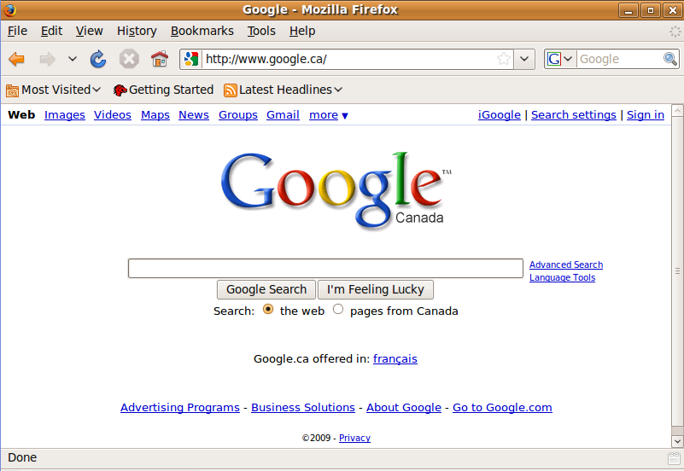

The secret of using a search engine such as Google lies in choosing the best key words or phrases to locate useful web sites.

Carry out a Search for Specific Information Using a Keyword or a Phrase

Suppose you have a special interest in mountain climbing and you would like to find websites that can give you information on mountains to visit in Nepal.

You can use one of the following keywords or phrases:
- mountain – gives about 268 000 000 possible sites
- mountain climbing – gives about 9 230 000 possible sites
- “mountain climbing” – gives about 1 590 000 possible sites
- “mountain climbing sites” – gives you 246 000 possible sites
- “mountain climbing sites” Nepal – gives you 4 120 possible sites

What did you do to narrow down the number of sites?
- mountain – search sites that contains the word “mountain”
- mountain climbing – search sites that contains the words “mountain” and “climbing”
- “mountain climbing” – search sites that contains the phrase “mountain climbing” and not the separate words
- “mountain climbing sites” – search sites that contains the phrase “mountain climbing sites” and not the separate words/phrases such as “mountain climbing” or “climbing sites”
- “mountain climbing sites” Nepal – look for websites where the phrase “mountain climbing sites” appear with the word Nepal.

From the above it is evident that you have to be as specific as possible in your searching criteria (and make no spelling errors) to get the best searching results. Always try different combinations and techniques until you get the desired results.

Here is an example of the search results:

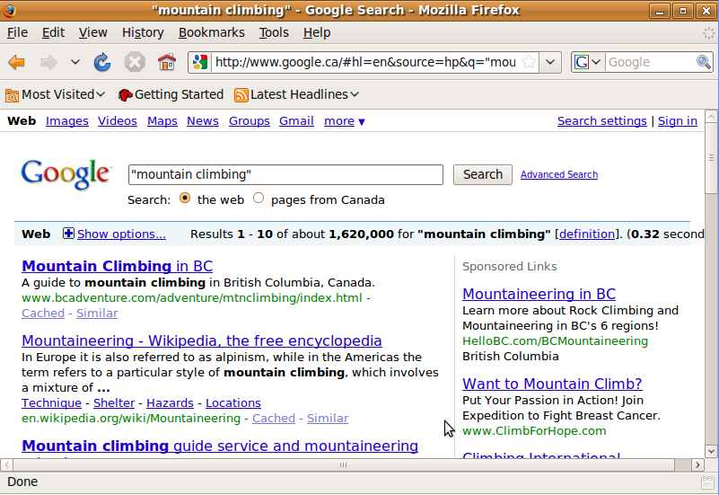

The search has been narrowed down to about 1,620,000 web sites.
Clearly the search needs to be narrowed still further. Keep on practicing until you are able to narrow your results so that you can work with the sites provided.

If you specifically want images, maps or videos on the topic, click on the relevant hyperlink at the top of the screen to further narrow your search.

Each of the web sites shown is shown as a hyperlink (the underlined blue text). You can:

- Click on a link to view the web site.
- Click the Back icon to return to Google.
- Scroll to the bottom of the Google web page and Click Next to view the next set of links.

Google Advanced Search

Most search engines have an advanced interface that narrow down your search.

- Click on the Advanced Search link.

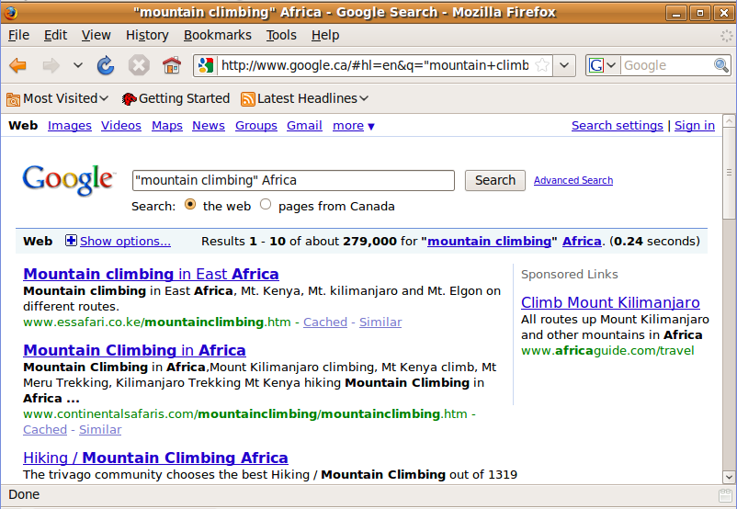

- The following screen shows how the advanced search can be further refined, in this case to English language sites that have been updated within the past year.

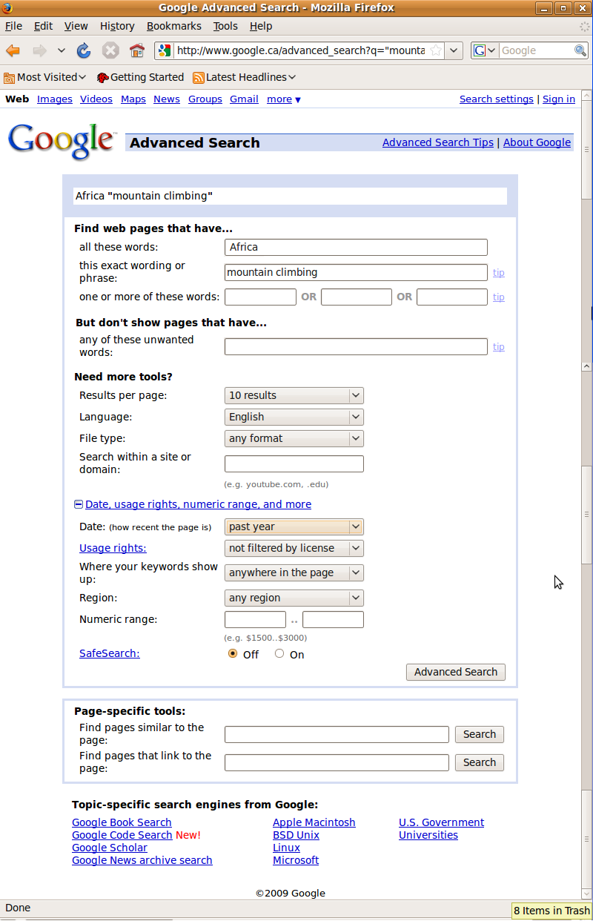
The results are significantly less.

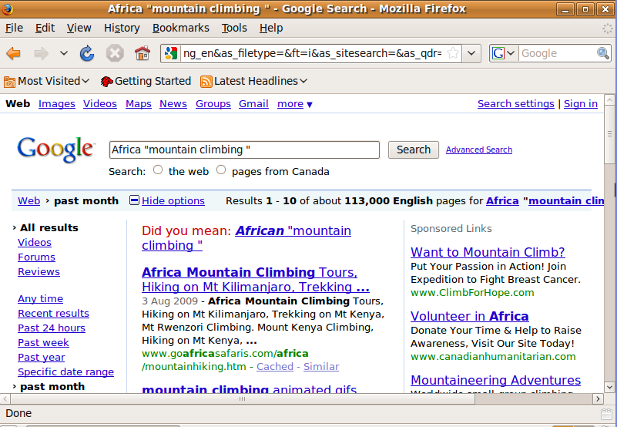

Now we have narrowed it down to about 113,000 sites. The more specific you can be, the more you can reduce the number of results.

The Google Advanced Search facility is a very powerful tool. You can also search by the exact phrase, by excluding words, by date and by file format.

It would be well worth your while to experiment with it and become fully conversant with its use. The Google site also contains tips and a help system.

Searching a Web-Based Encyclopedia and Dictionary

Web-based Encyclopedias

The web has opened up a vast array of electronic encyclopedias and dictionaries. Some are subscription-based, but some are also free to use.

The most used electronic encyclopedia is Wikipedia. Wikipedia is based on wiki-technology and is defined as:
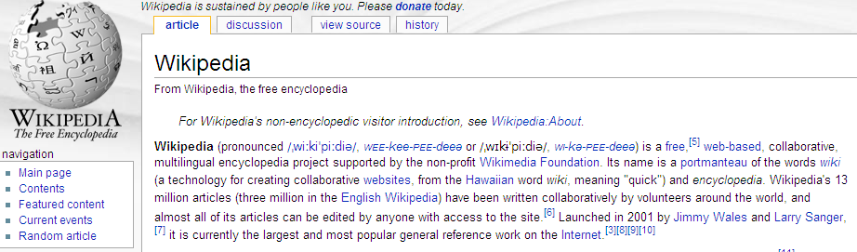
To search for a topic in an encyclopedia look for the search textbox. 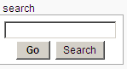
Enter your topic in the text box and hit Search. This will take you to text in the encyclopedia containing the words you have entered (wide search).

Wikipedia gives you an option – Go. This will take you to the page with the exact name. This will narrow your search significantly.

Check the search options in the encyclopedia you are using. Some gives you also an advance search option as discussed above.

Other examples are found at:
Encyclopedia Britannica: www.britannica.com

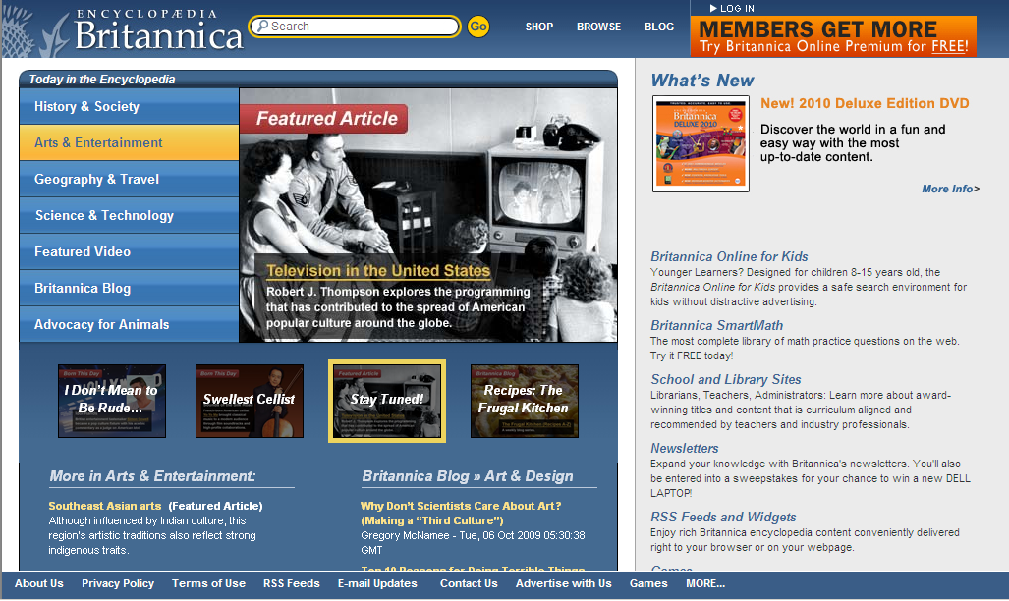
World Fact Book: http://www.bartleby.com
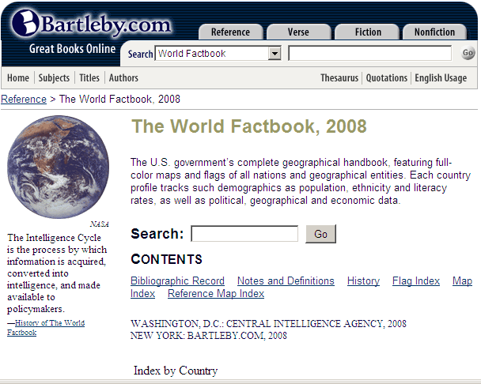

Web-based Dictionaries
There are several dictionaries available on-line. Some are free and others are subscription-based.
Examples are:
The Free Dictionary (includes a dictionary and thesaurus): http://thefreedictionary.com
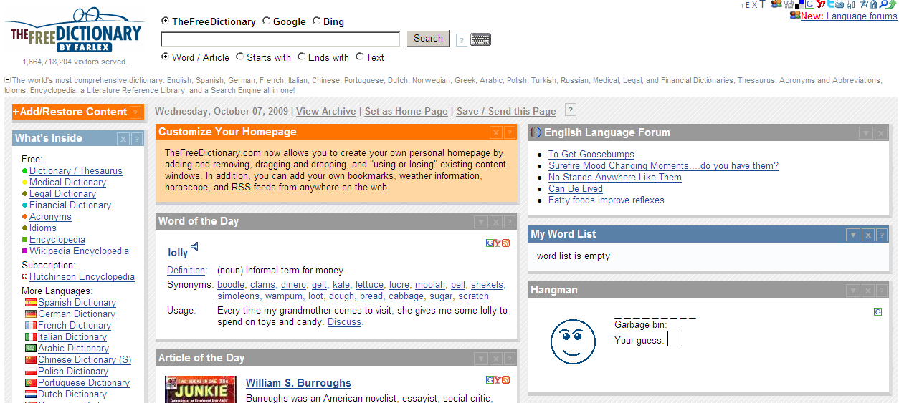
The website: http://www.worldreference.com allows you to choose from a myriad of options to translate.
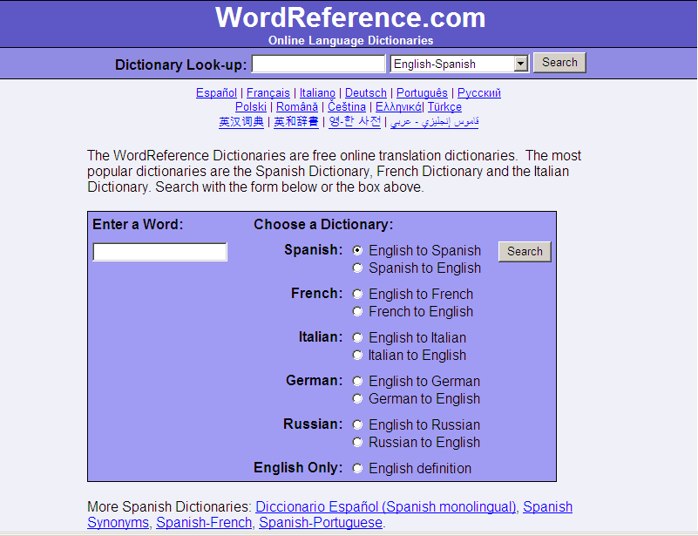

There are even search sites that search encyclopedias and dictionaries. An example is:
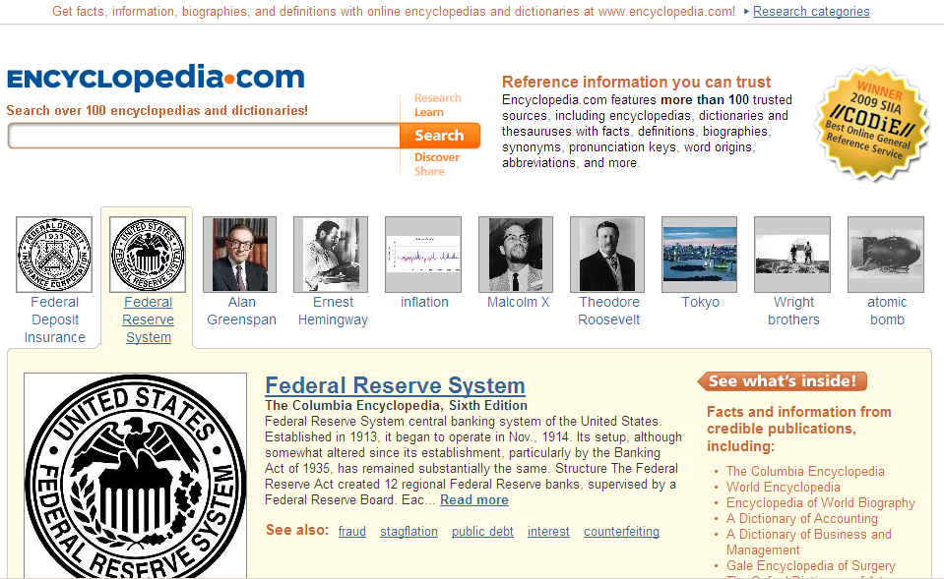

Evaluating Websites

The number of resources available via the Internet is immense - with more than 50 million World Wide Web pages out there. Nobody is controlling the Internet, what is going onto the Internet and what the quality of information is.

When you look at a website that has a lot of information that looks and sounds good, it is easy to believe that it is also correct! Unfortunately this is not always the case. Unlike textbooks, the Internet does NOT have a group of people to check that the information being provided is correct.

A web site that aims to give you correct information should always provide you with ways to check this.

The following items need to be checked and verified to evaluate a website:
- Who is the author? This can tell you about the credibility and reliability of the information published on the website.
- What is the purpose of the website? This can tell you if it is biased, opinionated or objective (factual).
- Is the information current? This must however be carefully considered, historical sites don’t need to be current, but news sites must be current.
- Is the website well designed, organised and easy to use? - Web sites can provide useful sources of information. However, if they are slow to load or difficult to navigate, search and read, then their contribution and usefulness will be lost.

Carefully consider a website before using the information published on the site.

Duplicate Text and Images from a Web Page to a Document

It is very easy to copy and paste from a website into a document. Before you do it, carefully consider copyright and intellectual property issues.

Copyright is a legal framework that protects creators of documents and artistic works against the publication and reproduction of their work without them receive remuneration. Copyright protection exists as soon as a work is created and does not need to be registered or carrying the © symbol. Copyright therefore protects the intellectual property of people.

Keep this in mind before copying anything from the Internet.

Copy an Image into a Document

Copying an image from a web site displayed in Firefox is a two stage process involving saving the image and then inserting it into a document.

- Right click on the image you wish to copy into a document.
- Click Save Images as ...

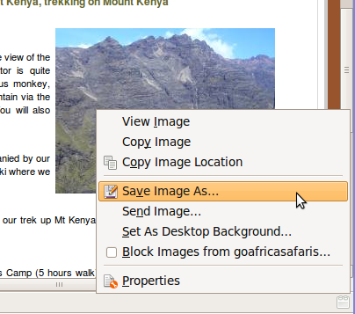

- Select the directory in which you wish to save the image.
- Give the image a suitable name.

- Click Save.

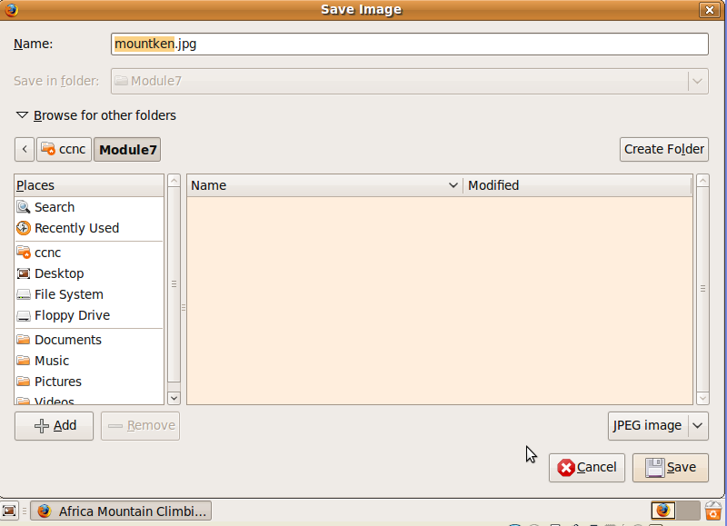

The image is now available for you to include in your documents using OpenOffice applications or other programs.

Remember to make sure there are no copyright issues regarding your use of images from the Web – refer to the “fair use” policy in your region.

Copy an Image from a Web Site to a Document

If your Internet connection is active, you may also be able to copy an image directly as follows:

- Hold down the left mouse button and drag over the image. It should change colour slightly.
- Choose EditCopy from the Firefox menu.
- Go to the point in your document where you wish to paste the image.
- Choose EditPaste from the application menu.

Copy Text from a Web Site

Depending on how a web site has been constructed, you may or may not be able to copy the text directly. If the following method does not work, you will first need to save the web page as a text or html file (see next section) and then copy the text from there.

- Go to the start of the text you wish to copy.
- Hold down the left mouse button and drag over the text you wish to copy.

- Choose EditCopy from the Firefox menu.

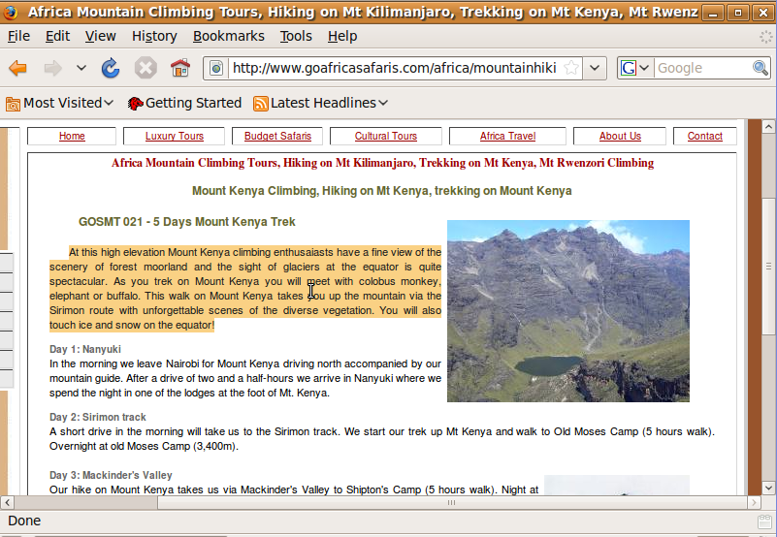

- Go to the point in your document where you wish to paste the text.
- Choose EditPaste from the application menu.

Save a Web Page to a Location on a Drive as a Text File or a html File

- Navigate to the web page you wish to save in Firefox.
- Choose FileSave As from the Firefox menu. This will display the Save as dialogue box.

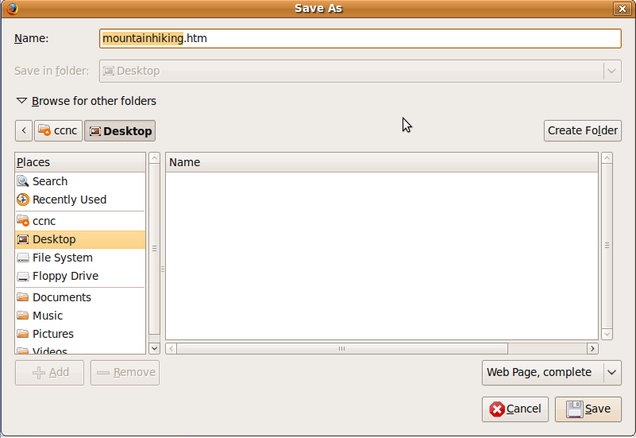

- Select the directory in which you wish to save the web page.
- Give the file a suitable name.
- Select the type of file you wish to save it as.

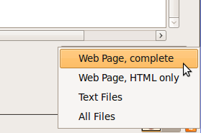

Download Text File, Image File, Sound File, Video File, Software, From a Web Page to a Location on a Drive (Be aware of legal and ethical issues)

Although the Internet is a wonderful source of information and software, it unfortunately has a negative aspect as it is possible to acquire illegal software from some sites. There are two things you need to keep in mind when downloading sites:

- Downloading illegal software or other electronic material across the Internet amounts to software piracy. This is both illegal and unethical as it infringes on the intellectual property rights of the developer.
- Software from illegal sites may contain viruses.

Download Software from the Internet

A very useful site for downloading software legally is Tucows.

The following example will illustrate how to download the current implementation of Wine from Tucows. (Wine is a program that allows you to run some Windows programs under Linux without having Windows on your machine.)
To download form Tucows:

- Locate the Linux section of Tucows by typing the following URL into the address bar: http://linux.tucows.com
- In the TUCOWS search bar, type in wine.

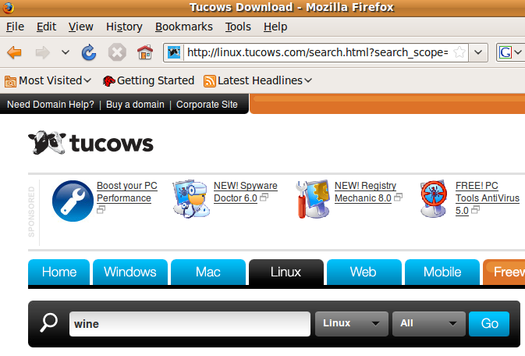

- Click the Wine link on the screen. This will display some information about Wine.

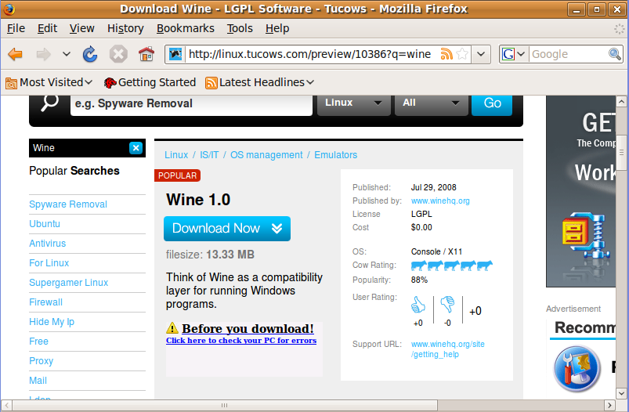

- Click the Download Now button.
- When asked whether you wish to open or save the file, select Save File and click the OK button.

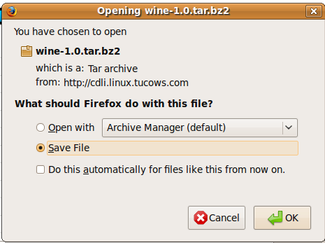

- Select a directory in which to save the download.
- Either keep the name of the file that is displayed (preferable) or give it a new name.
Note: If you do change the name of a file, be careful not to change the extension of the file as this could have unforeseen consequences. This is especially the case of files that will be used on Windows systems. On Windows systems the file extension has a special meaning. For example, you can tell executable files in Windows by the fact that they have an exe extension. In Linux, you can only determine whether or not a file is an executable by viewing its properties. An executable file in Linux may not even have an extension. However, even in Linux some extensions such as rpm, tar and zip do have special significance.

Download Text Files

There are a number of sites where you can download books free of charge. One of these is Project Gutenberg. The URL is www.promo.net/pg/

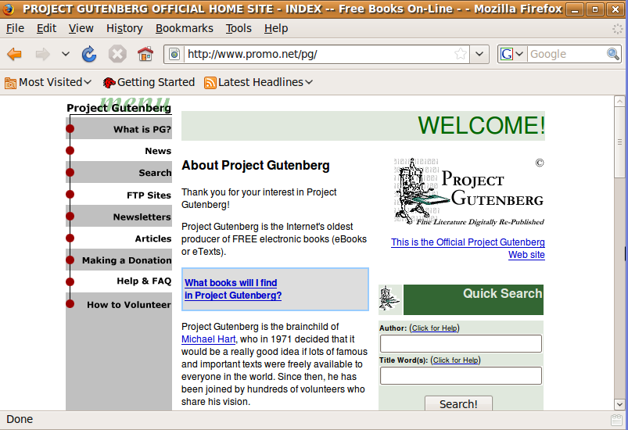

In this case we will locate a specific book, Around the World in 80 Days by Jules Verne.

Follow the following instructions:

- In the Quick Search window, search for Jules Verne under Author, and Around the World under Title Word(s), and press the Search button.

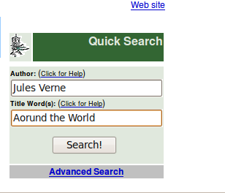

- Click on the title to go to the download page.

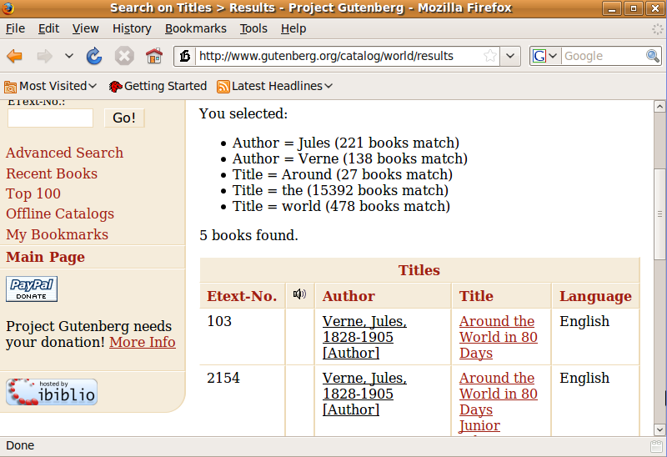

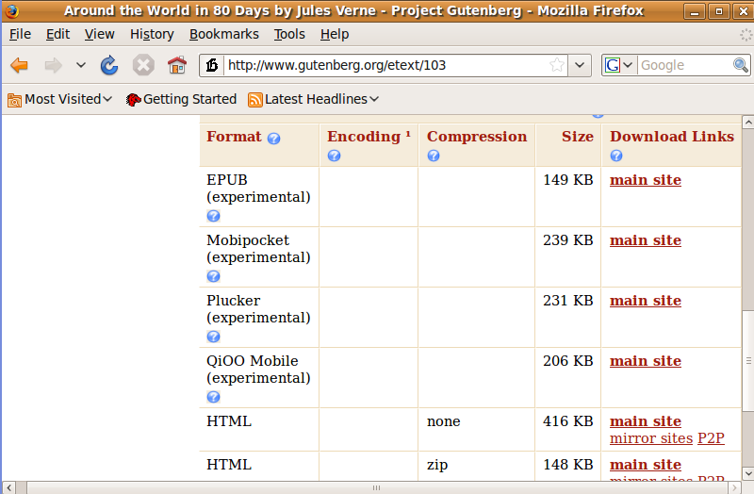

- Click on one of the links to begin the download.
- The next screen shows the HTML download.

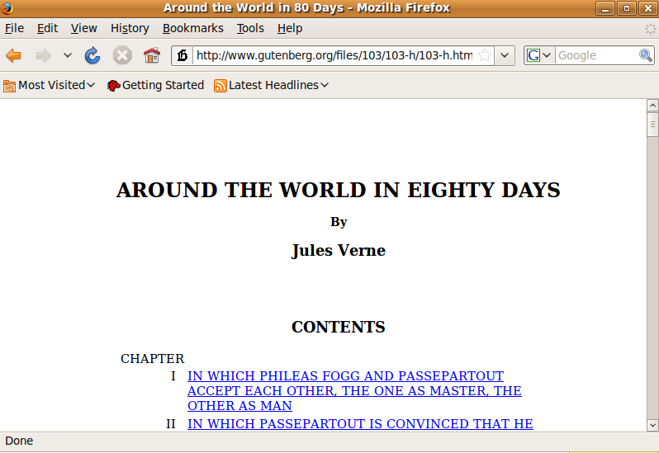

Download Sound and Video

Most computers have sound cards which enable you to play music and speech files. All are stored as sound files of one type or another. There are a range of different formats. One of the most popular is mp3 which compresses the file while still providing good sound quality.

Similarly, movies can be stored as video files.

In order to play sound or video files, you will need to have the appropriate software installed on your computer.

The process of downloading audio and video files is exactly the same as that described for software and text files. Begin by doing a search for audio or video files you are interested in, and then download.

Note: Not everything on the Web is downloadable. Understandably, content owners are often concerned that their content is not distributed illegally, and there is often a technical restriction placed on files such as audio and video. Only download from trusted sites with content that is copyright free.

Printing a Web Page

Preview a Web Page

Previewing a web page will enable you to see what it will look like when printed.
- Choose FilePrint Preview from the Firefox menu.

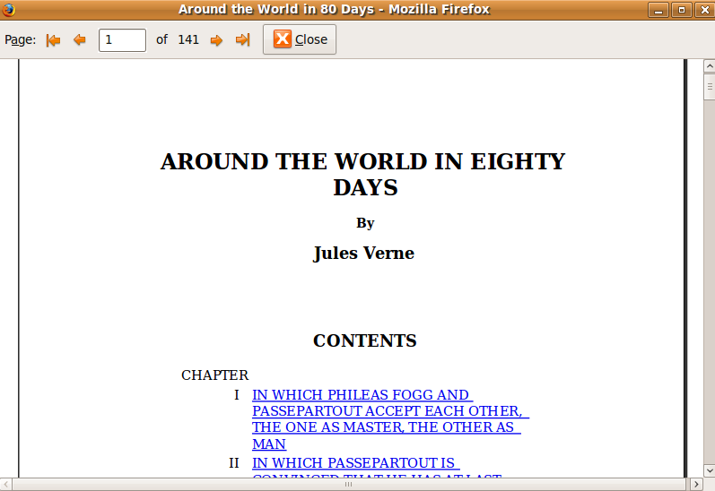

- Scroll through the pages using the arrow buttons at the top of the preview window.
- Click the Close button to return to the normal Mozilla window.

Page Setup

Before printing, you may want to change some of the page setup options.

- Choose FilePage Setup from the Firefox menu.

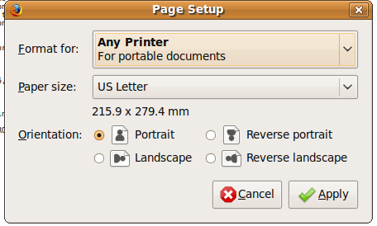

- You can set the format for your particular printer, change the paper size, and set the orientation. You may need to set your page orientation to Landscape when you are printing Web content that is fairly wide on the page.

Note: It’s often wise to print a test page when you are not sure what the content will look like printed, rather than printing a complete document that can’t be read.

Printing

Choose web page print output options such as: entire web page, specific page(s), specific frame, selected text, number of copies and print

- Choose FilePrint from the Firefox menu.

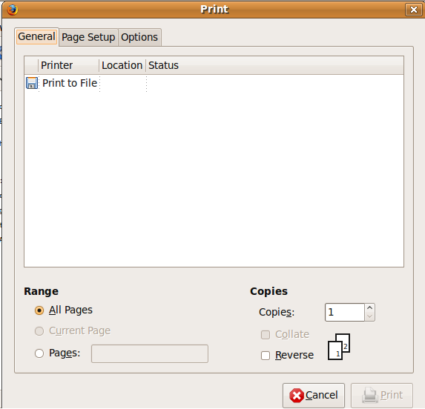OR 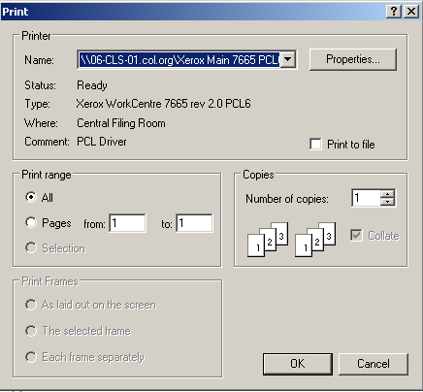

- In this dialogue you can set the following:
- Print to the printer or a file: If you do not want to print to the printer, but to a file, select Print to file, you will be prompted for the file name and location.
- The printer to use: Select the printer by clicking on the drop down arrow next to the printer name. The dropdown menu will display all the printers that are installed on your computer.
- The range of pages to be printed: The default is All pages. To select a different range of pages, select the Pages radio button and enter the start and end page numbers. Fill in the spaceor if it does not display the from: and to: option, type in the pages as 3-14 (note, there are no spaces between the page numbers you have entered).
- Number of copies: Enter the number of copies you wish to print in the corresponding window.
- Print frames: Some web sites are made up of frames. These are boxes on the screen which can be dealt with as units. If the web page contains frames, you can select how you wish these to be printed.
- Click Print or OK.

Use of Web Forms

The Web makes it easy to conduct surveys or having polls. Access a website such as:
www.gmail.com
and indicate that you want to sign up for a gmail account. You will see a screen like:
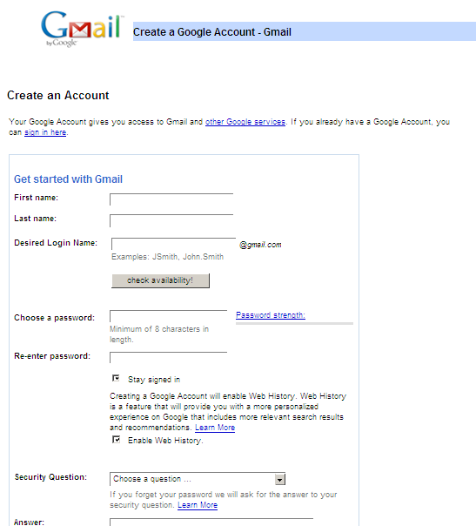

You need to fill in the electronic form to register for a new e-mail account.

Forms consist of the following:
- Information and questions that are text items entered by the creator of the form and cannot be changed.
- Text boxes – where you have to enter text in a box.
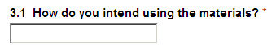
- Drop-down menus or list boxes – where you have to click on the down-arrow and you get a list that you can choose one item from.
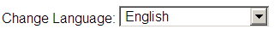

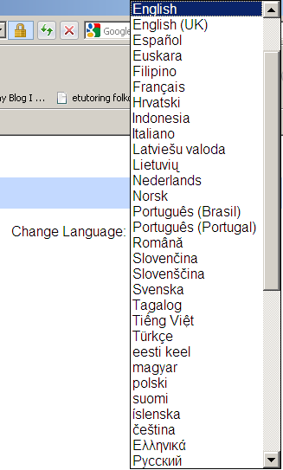

- Check boxes – a check box is a space where you can enter a tick to agree.


You can normally tick more than one answer to a question when using check boxes.

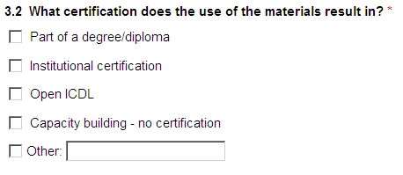

- Radio buttons – a radio button is normally associated with a specific choice. You cannot have more than one radio button selected in a question.

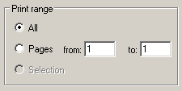

Forms normally have a submit button at the end to submit the response electronically. 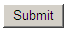 As soon as you hit the submit button, it will be submitted and you do not have access to your responses anymore. Make sure that before you hit the submit button, you have checked your responses.

Luckily some forms have a reset button to hit. This will delete all your responses and you can start from the beginning of the form.

Some forms cannot be submitted online and can be printed and faxed to submit responses.
An example can be found at:
http://www.lib.umd.edu/guides/webcheck.html
It is advised that you use this form to practice your evaluation of websites skills on page 46. Print the form for your own records.

Summary

This section introduced you to some techniques for searching the Web for specific information. Doing effective searches is a very important skill because of the vast amount of information available on the Web.

You also learnt how to copy images and text from a Web site to another application, how to download files from a Web site to your computer and how to fill in web forms.
.
Finally, you learnt how to print your web pages to a file or to your printer.

Ensure that you are comfortable to complete the following:
- Perform a basic search and an advanced search using the Google search engine.
- Copy text and images from a web page to another document.
- Download a file from a trusted web site to your hard drive.
- Complete a web-based form.
- Print a web page.

Electronic Mail using Evolution Mail

Section Overview

e-mail is one of the most important communication technologies developed and is used by many millions of people worldwide. e-mail has many advantages, and a few disadvantages as well.

In this section you will:
- understand the structure of an e-mail address
- understand e-mail etiquette
- learn about the security issues surrounding e-mail

Concepts and Terms

What is an e-mail?

e-mail or email is the abbreviation used for Electronic mail.

e-mail is the exchange of digital messages.

According to Wikipedia “e-mail systems are based on a store-and-forward model in which e-mail computer server systems accept, forward, deliver and store messages on behalf of users, who only need to connect to the e-mail infrastructure, typically an e-mail server, with a network-enabled device (e.g., a personal computer) for the duration of message submission or retrieval. Rarely is e-mail transmitted directly from one user's device to another's.”

To communicate via e-mail you have to obtain a valid e-mail address.

Mail Server

e-mail is sent and received through electronic "post offices" known as mail servers.

To read your e-mail, you download it from the mail server. 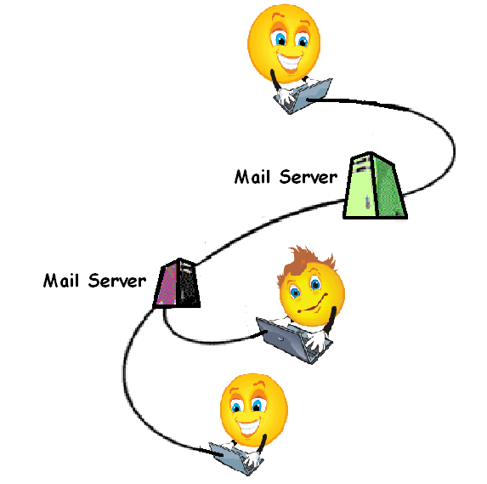

e-mail Client

Normally an e-mail client is the application which resides on every computer. Mail is downloaded from the mail server to the mail client. This can present a problem if you are away from your computer, especially if you are in a foreign country.

e-mail Software

You need to have the relevant software to send and receive e-mails. Examples are Microsoft Outlook or Mozilla Thunderbird.

Once you enter the address of the recipient, compose your message and click Send, your e-mail software handles the delivery.

Structure of an e-mail Address

An e-mail address can readily be distinguished from a web address (URL) by the fact that an e-mail address always contains a @ symbol while a web address never does.

The structure of an e-mail address is:
mailboxname@domain

For example, in the address:
josephine@ct-services.co.za
- josephine is the unique name of the mailbox. Usually the mailbox has a name which relates to the user. In this case she has used her first name. There cannot be 2 addresses with the sal name in the same mailbox.
- ct-services.co.za is the name of the domain to which it is attached.

Sometimes you will find e-mail addresses that have the form:
josephine.taylor@ct-services.co.za

In this case the period between the first name and surname has no special meaning. A hyphen could equally well have been used.

There can be many mailboxes attached to the same domain. In this case only the part to the left of the @ symbol would change. Thus another mailbox attached to the above domain might be info@ct-services.co.za

Uses of e-mail

e-mails are the most common used communication technology. It can be used to:
- Communicate
  - at personal level (at a fraction of the cost of snail-mail-post)
  - speedily – it is quick to deliver and to respond
  - at business level with buyers and sellers
  - asynchronys – you can send a message and the recipient will receive it when he/she open the e-mail program
  - can attach photos and videos
e-mail is about communication that is fast, efficient and inexpensive.
- Inform people – e-mail is a great way to let for example sellers know about market activity, recent sales, and showings that may have taken place when they were not home.
- Forward information – information can be forwarded easily and effectively.
- Speed up responses and delivery by sending e-mail reminders.
- Exchange documents - You can send an entire file via e-mail.
- Having e-mail also allows you access to mailing lists. A mailing list allows a group of people with common interests to exchange messages on that topic. When you send mail to the list, everyone who is subscribed to the list sees your mail.
- Multiple recipients – You can send one e-mail to multiple recipients.
- Brainstorming and problem solving - Although brainstorming and problem solving typically occur in face-to-face meetings, we can use e-mail to send documents for comments, ask for different views and get input into matters in discussion. It will definitely save on travelling costs and scheduling challenges.
- Record keeping - Unlike telephone and face-to-face conversations, e-mail "conversations" provide a built-in record of what you've asked for and what information you've received. Just remember to save it called archiving.

Advantages of e-mail

- Speed: e-mail is usually delivered within seconds to the recipient. The only delay occurs in the time taken by the recipient to check his/her e-mail.
- Low cost: The only costs are the line costs. Usually many e-mails are sent at once, reducing the cost even further.
- Attachments: Documents, images, sound and video files can be sent with e-mail messages as attachments. This further saves cost of delivery of heavy and bulky articles. The recipient can print the attachment or save it to the appropriate medium.
- Reliability: Although e-mail is occasionally lost through technical problems on the Internet, it is much more reliable than ordinary mail. Electronic receipts can be requested by the sender to confirm that the mail has arrived at the recipient.
- Security: Using encrypted links, sensitive and confidential messages can be sent across the Internet. Sending hard copies of messages has a much greater security risk.
- Multiple recipients – You can send one e-mail to multiple recipients.
- Record keeping - Unlike telephone and face-to-face conversations, e-mail "conversations" provide a built-in record of what you've asked for and what information you've received. Just remember to save it called archiving.

Disadvantages of e-mail

- You could send and receive viruses and malware through attachments if you don't scan it.
- Your inbox can be flooded with spam and unwanted advertisements from many sources. Ensure that you know how to handle and manage junkmail.
- e-mails "bounce" between different servers all over the world before reaching you and could be stolen or modified by any knowledgeable hacker.
- e-mail can become time consuming for answering complicated questions and misunderstandings can arise because cultural differences in the interpretation of certain words. The telephone, is much better for providing detailed answers or if you feel that the question is not absolutely clear.
- e-mail communication can be misunderstood. Be aware of e-mail etiquette and the language you’re using in e-mails. Sensitive matters must not be communicated by e-mail. e-mail can become impersonal or misunderstood.
- A long e-mail could cause the recipient to lose interest and stop reading the e-mail altogether.
- It is so easy to send e-mails, that people tend to forward a lot of e-mails to people. Avoid forwarding jokes and presentations to people. It blog up and slow down systems.
- Sending and receiving big attachments, media files and presentations take up valuable disk space and slow systems down. Avoid sending big files to people. If you receive big files, either delete or save it and delete the e-mail.

- You must have a computer or something that connects you to the Internet, which only some can afford.
- If your computer gets a virus or breaks down, there will be no way of e- mailing until it is fixed or you have to use another computer.
- Slow Internet connections can fail easily when sending and receiving big e-mails. Make sure that your recipient’s connection can handle big files.
- e-mail can compromise the security of an organisation because sensitive information can be easily distributed accidently or deliberately. e-mail should be entrusted to well trained and trusted staff members.

Web Based e-mail

Web-based e-mail or Webmail is an e-mail service is primarily accessed via a web browser (e.g. Firefox or Explorer), as opposed to through a desktop e-mail client (e.g. Microsoft Outlook, Mozilla's Thunderbird or Apple Inc.'s Mail). Very popular webmail providers include Gmail, Yahoo! Mail, Hotmail and AOL.

A major advantage of webmail over application-based e-mail is that a user has the ability to access their inbox from any Internet-connected computer around the world. You do not need to have a mail server or special software. It offers you plenty of storage, effective spam filtering, a fast interface and desktop e-mail access from any connected machine or device, even on some cell-phones. However, the need for Internet access is also a drawback, in that one cannot access old messages when not connected to the Internet.

To access your mail, you would be required to enter a user name and password. Once these have been accepted, you have access to the mailbox, which from there on functions in very much the same way as an ordinary mail client.

Web based mail clients need to be managed carefully. Usually there are quite strict size limitations. This means that they will fill quickly unless unneeded messages are deleted.

Some organisations provide additional to the normal e-mail, services such as web based mail linked to your own domain.

Web based e-mails can be set up free on sites like Hotmail, Yahoo Mail, Gmail, and Eudoramail. There are also sites which charge a fee. These would offer larger mail boxes and more features. These sites would be more suited to the business user who has to travel frequently.

Most of us use free e-mail services to create e-mail accounts and maintain them. There are real disadvantages of using free web-based e-mails, and you need to be aware of it.

- The most important disadvantage is the security and privacy. We cannot control our privacy and security of our e-mails and profile data.
- You can receive a high volume of unwanted e-mails (spam) even if you don't provide your e-mail addresses to a third party. Many free e-mail services sell their e-mail addresses to various marketing companies.
- Most of the free web-based e-mail services provide simple web based e-mail facilities where you can't do many modifications.
- Free web-based e-mail services are a good advertising and marketing medium.
- Some companies and individuals pay less attention to the e-mails they receive from free web-based e-mail services addresses as they experience that most of them are spam.

e-mail Etiquette

Although e-mail tends to be less formal than written communication, a poorly written and structured e-mail can cause offence. This is especially true in a business environment. Used correctly, it is a valuable business tool.

Below are some points to adhere to when writing e-mails:

- Insert a meaningful subject heading. Users scan their mailboxes before opening e-mails. A brief accurate subject heading can help them decide the relative importance of mail. Many users delete mail that is suspicious. e-mail with empty or meaningless subject headings would fall into this category.
- Use an appropriate mode of addressing the recipient. There is a tendency to start e-mail with the greeting Hi Jo. This level of familiarity and informality may be appropriate if you know the person you are sending the e-mail to. When sending a business e-mail, rather be too formal than too casual. Remember, many people may regard the casual mode of address as disrespectful.
- Be concise and to the point.
- Be clear but brief in constructing e-mail messages. In is quite common for users to receive a hundred or more e-mails at a time. Take into account that they might be under pressure when they receive your e-mail. Use correct paragraphing and headings to enhance the clarity.
- Check the spelling of your e-mail. It is very annoying to receive e-mail with many misspellings. Most e-mail clients allow you to spell check your e-mail.
- Likewise check the grammar of your e-mail.
- Do not use all upper case (capital) letters or all lower case letters when writing e-mail. Use the correct case for text. Even friends could react negatively to such lazy construction. Writing in capital letters in an e-mail means that you are screaming.
- Do not use slang, use emoticons and abbreviations sparingly.
- Include a signature at the end of your e-mails. This should include your full names, the capacity under which you are writing, your e-mail address, phone and fax numbers and any other information which might be relevant to the communication.
- If you respond to someone’s e-mail, answer all questions chronologically.
- Do not attach unnecessary files, especially big media and presentation files.
- Avoid forwarding jokes and “puppy and lovey” presentations to lots of people. If you want to share it with an individual, make sure that he/she wants it.
- Do not forward chain letters.
- Do not overuse the high priority option.
- Read your e-mail before sending it. Make sure about the message before it is going out.
- Check the recipients. Do they need to receive the e-mail? Make sure that you are not sending private e-mails to wrong recipients.
- Do not use e-mail to discuss confidential matters.

Security Considerations

How to Identify Unsolicited e-mail - Detailed Instructions

A distribution list is a set of e-mail addresses which are given a single collective name. A distribution list can have tens or hundreds of thousands of names on them.

Once a distribution list has been compiled, e-mails can be sent to every name on the list by sending it to the name of the list. In other words, it is as easy to send the mail to a hundred thousand recipients as to one.

This has led to a whole industry of creating and selling distribution lists. These lists are then used to send unsolicited e-mail to people on the lists. Unsolicited e-mail, known as spam is a major problem for both users and the Internet. The transmission of millions of messages across the Internet wastes valuable bandwidth and causes deterioration in Internet performance. For users, spam not only causes irritation but also fills up mail boxes.

To deal with the problem, some countries are now introducing legislation to prohibit spam. Some ISPs make use of special anti-spam software to block spam. Sometimes this software makes use of known sources of spam while at other times it uses special techniques to analyse the content. It is also possible to install anti-spam software on your computer.

Be aware of the danger of infecting the computer with a virus by opening an unrecognised mail message, an attachment contained within an unrecognised mail message

e-mail has been one of the major sources of the spread of computer viruses in recent times. These viruses are usually hidden in attachments to e-mails. There are numerous effects of these viruses.

As Linux is relatively unaffected by viruses, these effects apply mostly to non-Linux systems. However, the situation could change.

Viruses could:
- make your computer run more and more slowly to the point where it is inoperable
- delete data or entire hard drives
- change data
- send information stored on your computer back to hackers
- install programs on your computer which monitor your work and send details back to hackers
- use your computer to send infected e-mails to users in your e-mail client address book

On non-Linux systems, one of the standard actions you would take is to install anti-virus software that is able to scan e-mail. However, as the threat to Linux systems is very low, there is little anti-virus software available.

Although the viruses may present little direct threat to a Linux system, it is possible for viruses to lie dormant in files stored on a Linux system and be transmitted to non-Linux systems when mail is sent or forwarded.

You should take the precautions listed below. If you are unsure of an e-mail, do not open it or even preview it. Rather delete it.

- check the e-mail address to see if it is a known source
- if you do not know the sender, check the domain. Be particularly wary of unknown senders using web-based mail
- check the subject heading of the e-mail
- check if there are attachments. Be very careful of e-mail from unknown sources which have attachments
- as we are all becoming increasingly dependent on e-mail, we are often force to take certain chances. In order to deal with possible loss, make regular backups on removable media such as CD.

Digital Signatures

Digital signatures provide a way of verifying that an e-mail is genuine and from the sender.

The process of using digital signatures makes use of a public key and a private key. If you wish to communicate with others using digital signatures, you will make your public key available to everyone but will keep your private key secret.

In order to use digital signatures, you would need special software.
First the sender's software compresses the message into a much smaller block of text, the message digest, by a process called hashing. Hashing is a one way process as you cannot derive the original message from the text that has been hashed, even if you know the hashing algorithm.
Once this has been done, the message digest is encrypted using the private key. The encrypted message digest is the digital signature which is then attached to the e-mail.

The receiver's software then decodes your digital signature using the public key to create the original message digest. At the same time it also generates a message digest from the e-mail using the same hashing technique. By comparing the two message digests, the receiver can determine the genuineness of the e-mail.

Summary

This section introduced you to electronic mail and some of the security issues that come with it. Electronic mail is a very important communication technology, but it also comes with the threat of viruses and others. Fortunately, for now, Linux operating systems are subject to a very low level of threat from viruses.

This section also discussed some of the etiquette considerations to be considered when using e-mail.

First Steps with e-mail

Section Overview

This section is meant to give you some hands-on experience using the Evolution e-mail client in Ubuntu.

In this section you will:
- Understand the basic features of the Evolution e-mail client.
- Learn how to customise the Evolution workspace.
- Learn how to access available Help features in Evolution.

Opening Evolution Mail

- Choose ApplicationsInternetEvolution Mail from the Ubuntu menu.

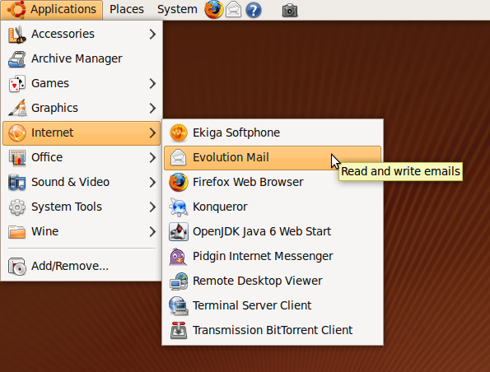

The Evolution interface appears as follows:

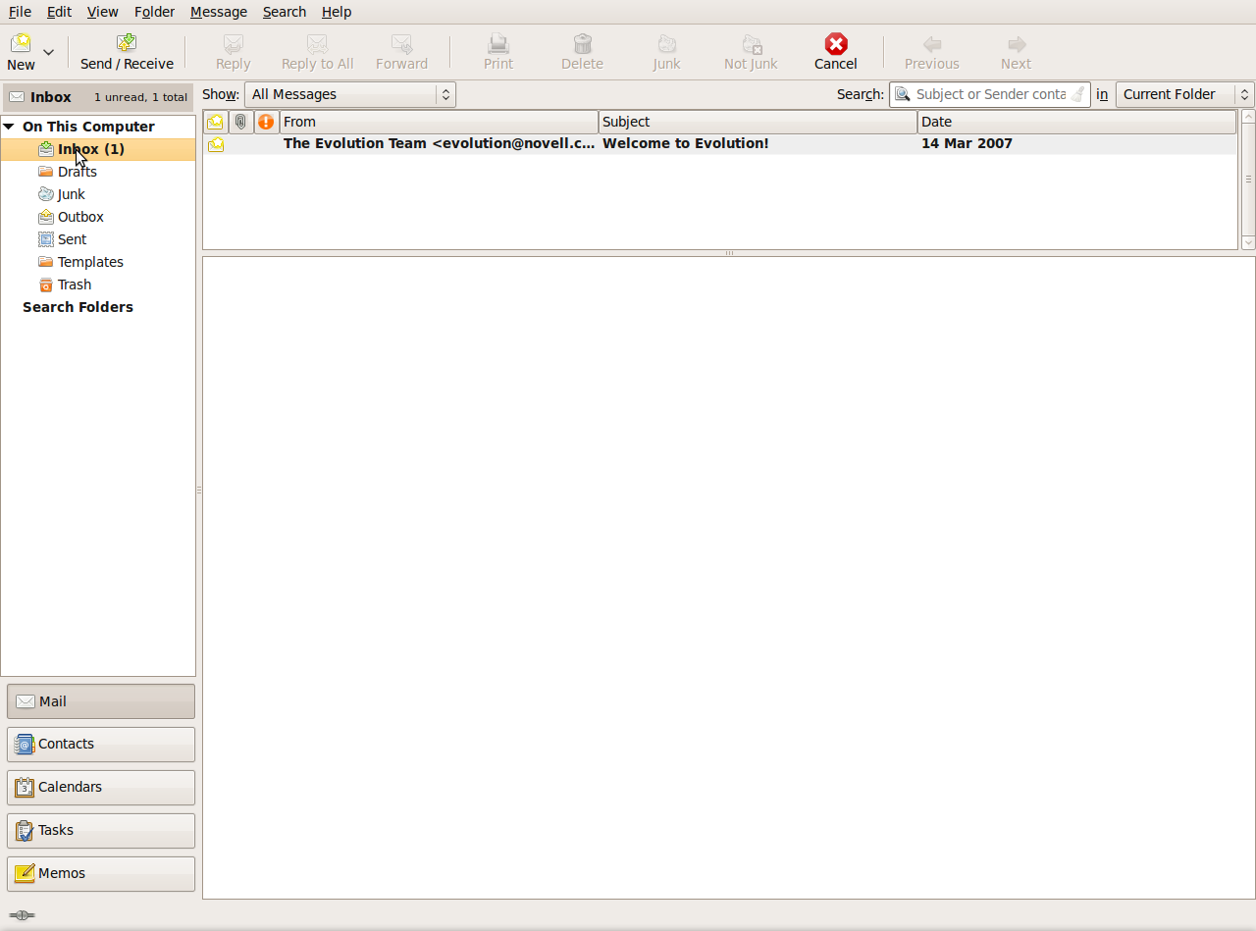

Close Evolution

Choose FileExit from the Evolution menu, or click the exit button.

Features of the Evolution Window

When you open the Evolution application, you will see running across the top of the Writer window a menu bar and a toolbar which displays a series of icons or buttons that you can click on when you want to perform certain tasks. The window is further broken down into three panes: a list of folders on the left, a list of messages on the top-right, and a preview pane on the bottom-right.

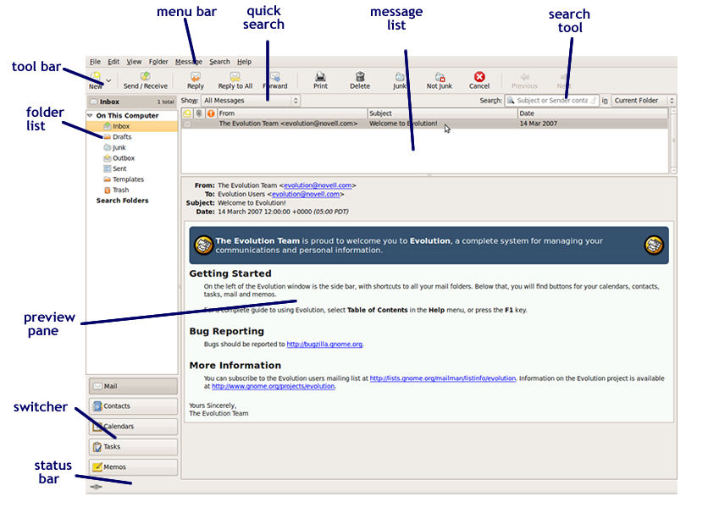

Switch off the Preview Pane

There are a number of reasons why you might not wish to have the Preview pane displayed. From a security point of view, it is better that it is not displayed. When it is displayed, Evolution has to read the message. This is sufficient to activate certain virus activity. However, viruses are not an issue so far with Linux, so it is OK to leave it viewable if you prefer.

To switch it off choose ViewPreviewShow Message Preview from the Evolution menu.

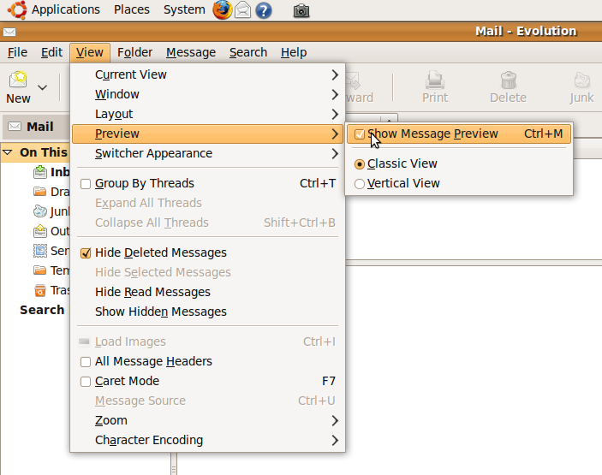

Use Available Help Functions

The help system for Evolution consists of an electronic book divided into a number of sections. Each section may contain one or more chapters.

To open Help:

- Choose HelpContents from the Evolution menu, or press the <F1> key on your keyboard.

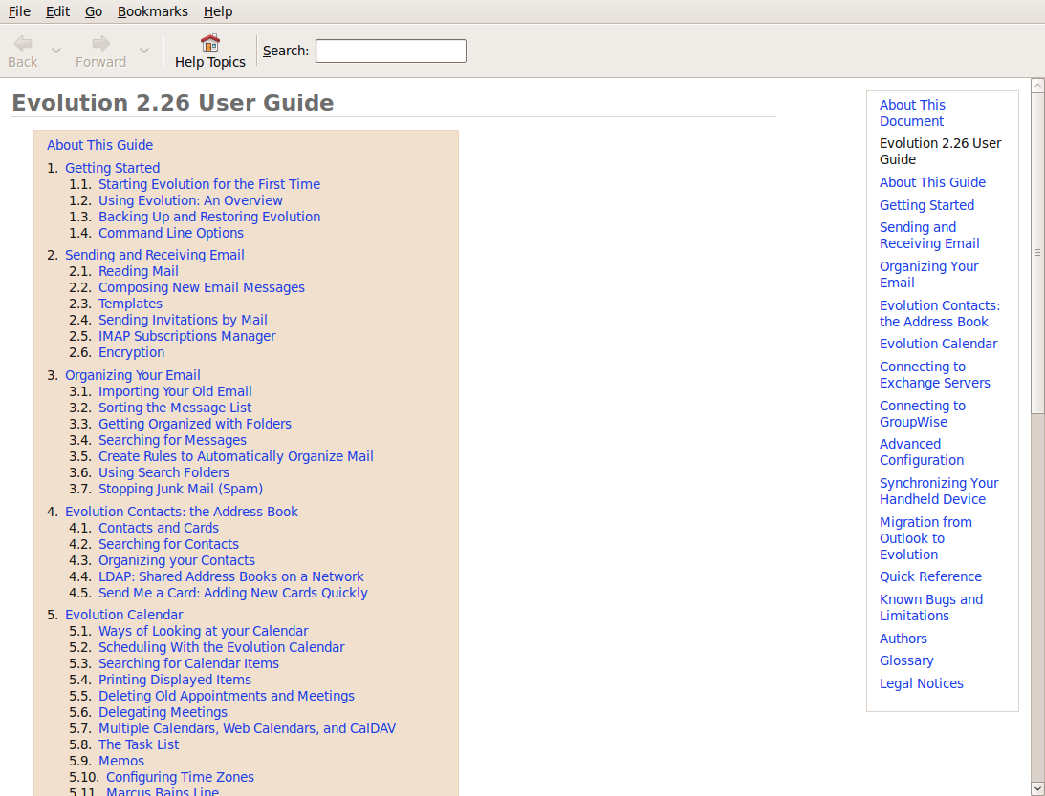

- The left hand pane consists of a list of the sections while the right hand pane is more detailed and has the chapters set out as a series of hyperlinks.
- Click on Using Evolution: An Overview.

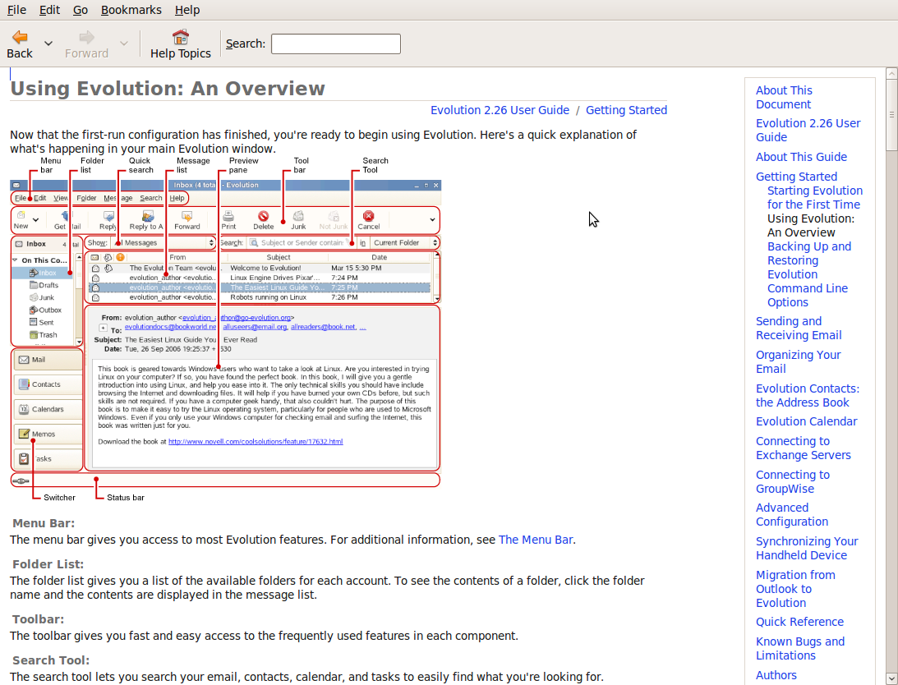

Display and Hide Built-In Toolbars

Changes to the toolbars are accomplished through the View menu.

- Choose ViewLayout from the Evolution menu
- Check the toolbars you wish to have displayed. Uncheck those you want hidden.

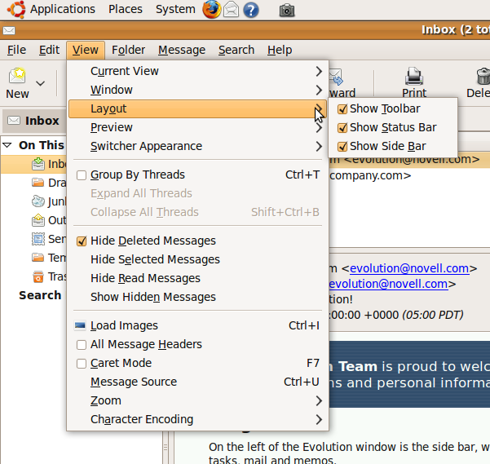

The Inbox and Outbox

- All receiving messages are placed in your Inbox.
- When you send messages, it is temporarily stored in the Outbox before they are sent.
- Deleted messages are placed in the Thrash (Deleted Items box)
- Saved draft messages are placed in the Drafts box.
- Sent messages are placed in the Sent Items Box.

The Message List

The message list is the top-right pane of your Evolution window. It contains a list of the messages you have in your active message folder.

You can switch between folders in the Folder List pane, on the left of your Evolution window. When you do, the message list will change.

The message list is split into columns by default:
- A From column, which lists the sender of the message
- A Subject column, which lists the subject of the message
- A Date column, which lists the date of the message.

You can sort your messages in the message list by clicking on any of the column headings to sort under that column.

Remove Message List Headings

By default the inbox displays messages according to who they are from, the subject and the date. Usually this is the information you need. You can remove these headings and add others. Remove a message heading:

- Right click on the column you wish to remove.
- Click Remove This Column in the context menu.

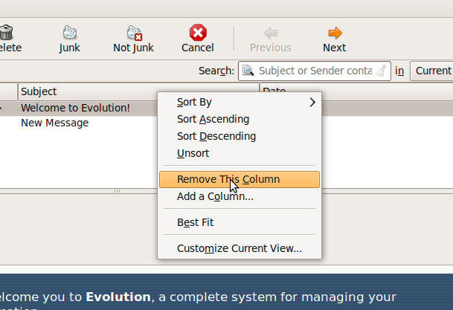

Add a New Message List Heading

- Right click on a column.
- Click Add a Column.
- A list of possible column headings will be displayed. Drag the column you wish to insert to the desired location.
- Click the Close button on the column list when done.

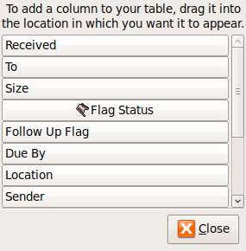

Summary

To assess your learning, make sure you are comfortable carrying out the following tasks in Evolution Mail:

- Open and close the Evolution e-mail application.
- Use the Help files to get information about using Evolution.
- Display and hide the Evolution toolbars.
- Modify the Message List pane.

This section introduced you to the basics of the Evolution e-mail application and showed how to get help when needed, and how to modify the application workspace.

Sending and Receiving Messages

Section Overview

In this section we will become familiar with receiving, opening, replying, and sending e-mails, and with downloading files attached to e-mails. Remember that e-mails can contain malicious content and files, so never open file attachments form unsolicited e-mails or e-mails from unknown sources.
In this section you will:
- learn how to open and close e-mail messages
- understand message flags
- work with file attachments
- reply to messages
- use spell check to check your messages before sending
- duplicate, move, and delete e-mail messages

Receiving, Opening, and Closing Messages

Receiving Messages

By default, Evolution checks for new messages when you open the application and every 10 minutes thereafter. To check for new messages any time:

- Click the Inbox folder in the left pane.
- Click on the Send/Receive icon to download messages and to send any outgoing messages.

Opening Mail Messages

Open a Single Message

- In the message list, select the message you wish to read by clicking on it. If the preview pane is open, the message will appear there.
- To open the message in a new window, choose MessageOpen in New Window from the Evolution menu, or double click on the message.

- Choose FileClose from the message menu when done, or click on the Close icon on the top-right corner of the message.

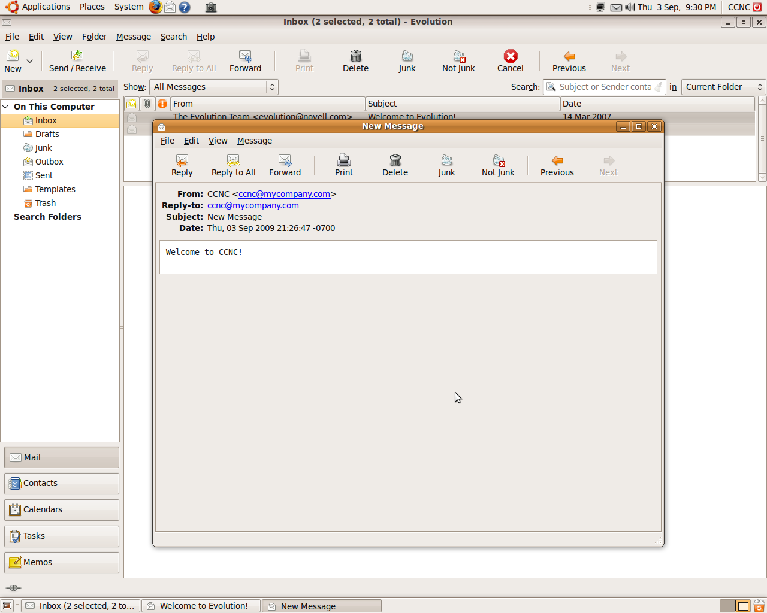

Open Several Messages

- Select multiple messages by holding down the <Ctrl> key and clicking on each of the messages.
- To open the messages in their own windows, choose MessageOpen in New Window from the Evolution menu.

Switch between Open Messages

When a number of messages are open, an icon for each will be displayed at the bottom of the screen, as shown in the figure above. These icons will also include windows of other applications that may be open.

Click the icon corresponding to the message you wish to read. This will make the message the active window.

Close a Mail Message

To close the message window, do one of the following:

- Click the Close icon in the message window.
- Choose FileClose from the message menu.

Marking Messages - Message Flags

You can manage the status of a message – it is called Message Flags. Before you can understand how to change the status, it is important to understand the status of a message.

If you open your mailbox, you can see different ways that messages are displayed:
- Unread messages are shown in bold and read messages in ordinary text in the inbox. In addition, an envelope icon is displayed to the left of the message. In the case of unread mail, this is a closed envelope. If you read a message, the envelope is open.
- Important messages can be marked with a red exclamation mark.
- If you send a file with your message (it is called a attachment), you will see a 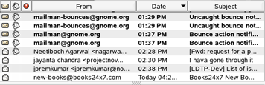or a 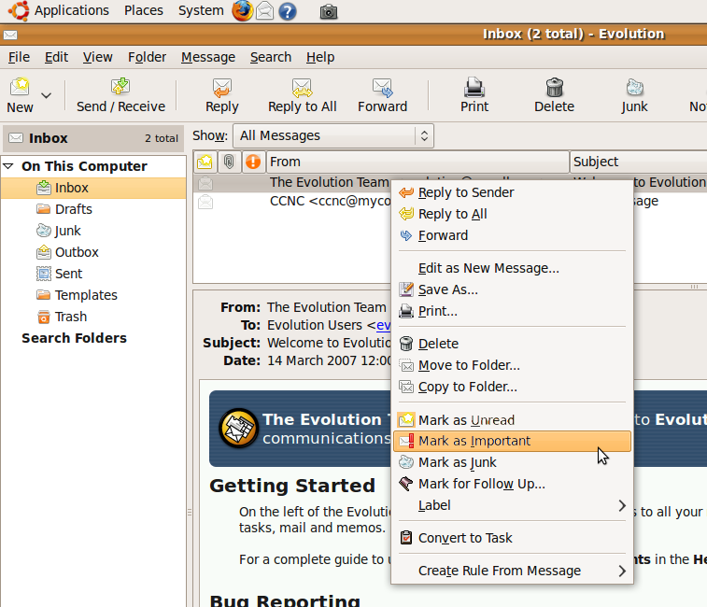 (small paperclip).

Important Flag
Read
Unread
Attachment

You can change the status display of messages in your mailbox. Go to the message, right click on the message. A context menu will appear.

You can do the following:

To Mark a Message as Important – Add a Red Exclamation Mark

- Right-click on the message.
- Click Mark as Important. The message is displayed in red with an exclamation mark.

To Unmark an Important Message – Remove a Red Exclamation Mark

- Right click on the message.
- Click Mark as Unimportant. (This option will only be available if the message is flagged as important.)

To Mark an Unread Message as Read without Opening it

- Right click on the message to display the Context menu.
- Click Mark as Read.

To Mark a Message that has been Read as Unread

- Right click on the message to display the Context menu.
- Click Mark as Unread.

Note: Both the Mark as Important/ Unimportant and Mark as Read / Unread are toggles. The option displayed in the context menu reverses the current status. Open and save a file attachment to a location on a drive.

e-mail Attachments

An attachment is a file that you send along with an e-mail message.

Note: Attachments are a major method for the spread of computer sources.

When you receive an attachment you have the option of saving it immediately without looking at it, or of opening it.
If it is a text file, it would be opened in your word processor.

An attachment could also be a spreadsheet, presentation, database file, video or audio file, or any other type of file.

Messages that have attachments are marked with a paper clip.
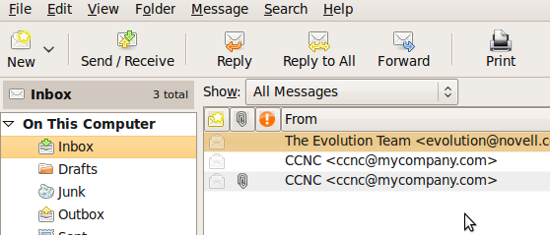

Save a Message Attachment

When you receive a message containing an attachment, there is an attachment icon visible. You can also see a Save button before the message, and a display button after it..
With these, you can save the attachments to your files pace or in an external application.

- Open a message with an attachment.
- Scroll down to the bottom of the message where the attachment icon is displayed.
- Click on the icon.
- Click Save As.
- The standard Save as window will be displayed in which you will be required to specify the directory location and name you wish to use.

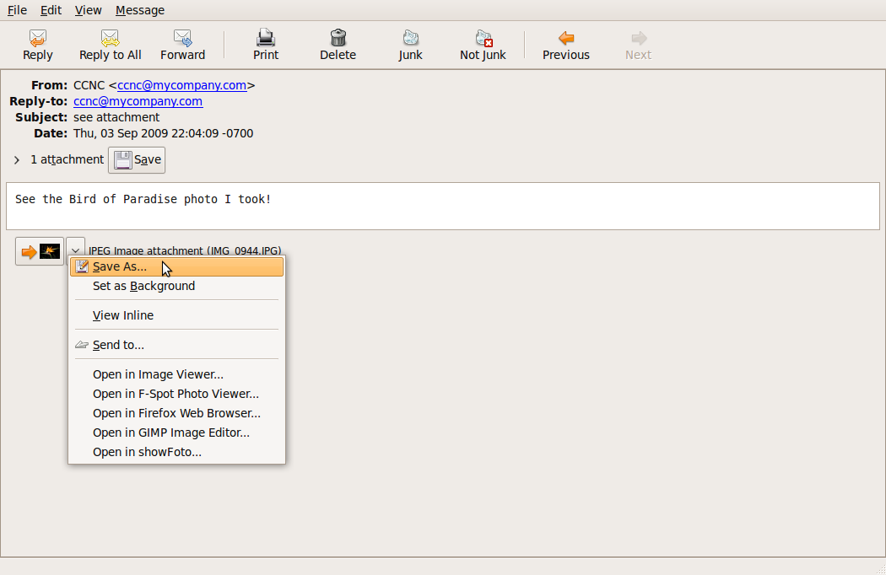

You can also hit the Save button.

Open Message Attachment

You can choose to open a message attachment directly. This action will load the associated application and open the file. For example, if the attachment was a word processor document, it would open in OpenOffice Writer.

- Select the Open option in the context menu.
- Use FileSave as if you wish to save the document.

Reply to a Message

Basic Terminology

You are now able to open, read and close an e-mail. You can also read and save attachments.

To reply to a received message, you must first understand the terminology used in replying.

First you have to determine who is the sender of your e-mail. You will find it in the From: ….. line at the top of the e-mail.

If the message is from a list (not an individual name) – DO NOT REPLY. A lot of unnecessary mails are sent to lots of people unintentionally by replying to a list.

Secondly you have to understand who are contained in the following fields:
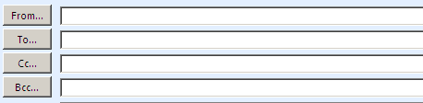

- From: - contains the e-mail address of the sender of an e-mail.
  - If the e-mail address indicates that it is from a list, do not reply if you are not 100% sure that you want to send the e-mail to all the people subscribed to that list. The e-mail will go to all the subscribers to that list.

  - If it is from a system, do not reply.

- To: - contains the e-mail address/es of the recipient/s of your e-mail. This field is automatically filled when you hit the reply button. MAKE SURE THAT YOU WANT TO SEND AN E-MAIL TO THAT SPECIFIC PERSON.

It is normally expected that people who receives an e-mail directly (Included in To:….), must respond to the e-mail.

- Cc: - is short for "Carbon Copy". Both the original recipient and all the recipients of the carbon copies see the To: and Cc: fields including all the addresses in them.

It is normally expected that people who receives an e-mail copy (Included in Cc:….), must only take note and don’t need to respond to the message.

- Bcc: - is short for “Blind Carbon Copy”. A copy of the message goes to every single email address appearing in the Bcc: field, but the recipients do not see the To: and Cc: fields including all the addresses in them. It ensures maximum anonymity of the people in the To: and Cc: fields.

How do you reply a message?

To reply to a message, you can hit the Reply or the Reply All button.

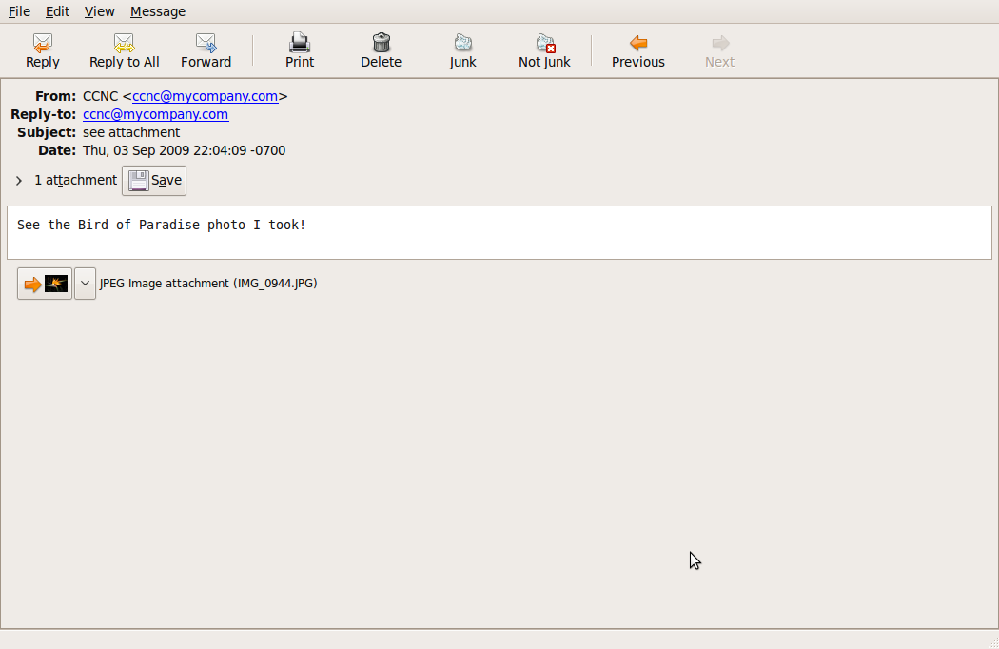

What is the difference between the ‘Reply’ and the ‘Reply to All’ Function?

Messages are often sent to a number of people at the same time.

When you reply to a message, you may reply to the sender only or to all the recipients as well as the sender of the original message.

To reply to the Sender only (check that it is not a list or a server):

- Open a message that has one sender and perhaps multiple recipients.
- Click the Reply button or <Ctrl>R.

This will display a new window containing:
- Your name in the From: field
- The sender of the previous message and the person you want to reply to in the To: field (check again if you have the right address in the To: field)
- The subject line appears as Re: ……….. to indicate it is a reply. The Subject will be the same subject as in the original message
- The text of the original message, sometimes preceded by > signs.
Add your new content to the message.

You can:
- Write your whole response at the top of the original message, leaving the message at the bottom for reference.
- If desired, you can delete part or all of the content from the original message.
- You can also add new content at any place in the message so it resembles a conversation. This is called "continuing the thread." If you make comments in the body of the original message, it is a good idea to type your replies in a different colour font such as red or to indicate which part of the mail is the original message and which part is your response. You can type:
  - You said: followed by a part of the original message
  - Your name: followed by your response
- Click the Send button.

Reply to All

Be mindful of the recipients receiving a message when you choose to Reply to All.

- Click the Reply to All button or press <Shift><Ctrl>R.
- Type in the reply.
- Click Send.

Sending a Message

Create a new message

- Click MessageCompose New Message from the Evolution menu, or click the New icon and choose Message.

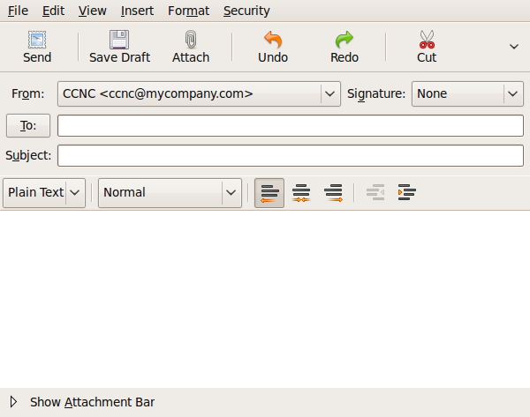
- Insert a mail address in the To: field:
- Type the full e-mail address of the person to whom you are sending the e-mail into the To field.
- If you wish to send the e-mail to more than one person, separate their e-mail addresses with a semi colon
- You can access your contact list by clicking on the To button. Select the contact from the list and press the Add button.

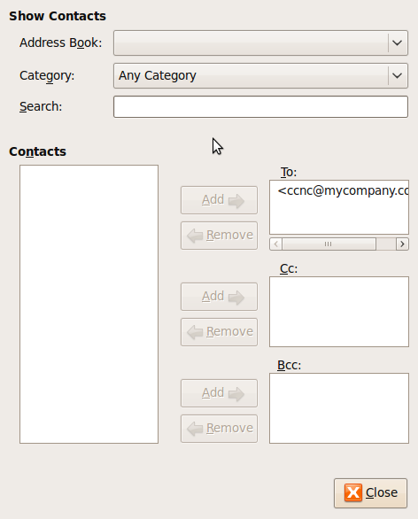

- If you like, you can Copy (Cc), blind copy (Bcc) a message to another address/addresses

Remember:
  - When you send a Cc, this will be indicated to all recipients of the mail. Recipients of a Cc will not be expected to reply. If you expect a reply from a recipient, include their e-mail address in the To window, not the Cc window.
  - If you wish to send a copy to one or more recipients but do not wish to disclose recipients’ names, use enter their names into the Bcc window.

- Enter a subject into the Subject window. Use a meaningful subject. Many users receive more e-mail each day than they are able to read. Use a subject heading that is meaningful and gives the reader as clear and concise indication of the contents of the e-mail as possible.
- Click Send when done.

Spell-Checking Tool

Use a Spell-Checking Tool for your emails when available. Make all changes such as: correcting spelling errors, deleted repeated words that are suggested by the tool.
Remember to check again before sending your email.
Note: The spell checking tool is not a substitute for good spelling, typing, and editing skills. Just because a word is spelled correctly, doesn’t mean it’s the correct word, as in this sentence:
I couldn’t right with that pen!

By default, spell checking is not enabled. To enable it:

- Choose EditPreferences from the Evolution menu.
- Click Composer Preferences.
- Select the dictionary for your location
- You may also select to check spelling as you type.
- Click OK.

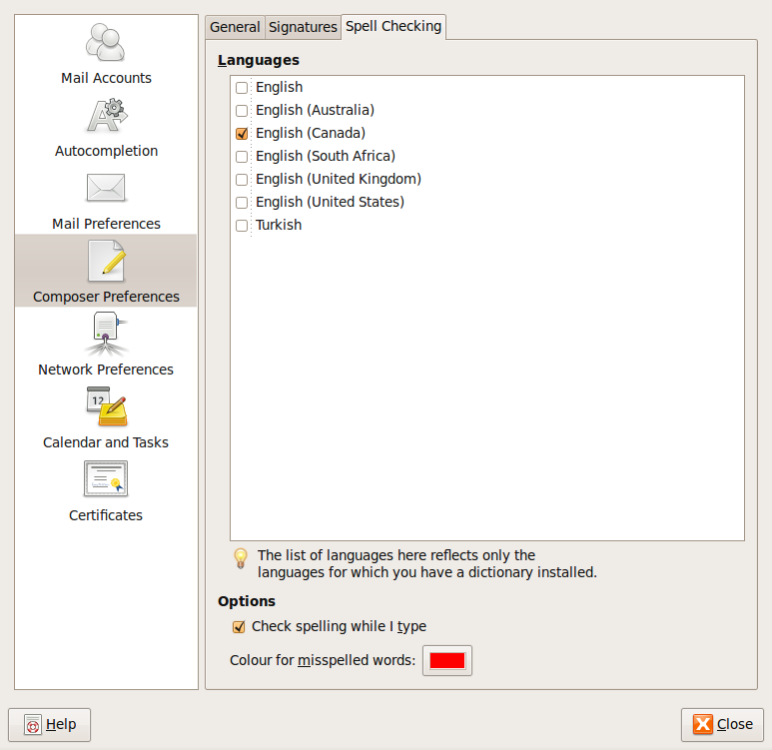

Spell Check a Mail Message

- Type your message. If you have selected to spell check as you type, Evolution will mark words it interprets as misspelled.
- When you have finished, choose EditCheck Spelling from the Evolution menu.

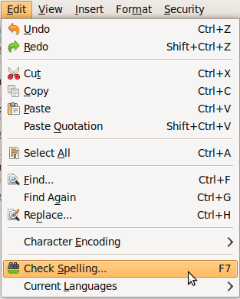
- You will be prompted with suggestions for incorrect words. Select a correction or press Skip if you do not wish to change the word. Pressing Ignore will skip all occurrences of the word.
- Click Close when finished.

Note: You may add new words to the dictionary by clicking the Add word button when Evolution encounters a new word in a document.

Attach a File to a Message

File attachments are a great way to share documents.

Whenever sending an attachment, please be wary of SIZE.

Many e-mail systems, especially web-bases e-mail, limit the size of the file attachment allowed, but most e-mail systems allow files of up to 2 MB or more.

It is very inconsiderate if you send big attachments, especially to people with slow connections.

To attach a file to a message:

- Type your message and subject, and add recipients.
- Click the Attach button 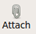 or choose InsertAttachment from the Evolution menu.
- Locate the directory in which the file is located and select the file.
- Click OK.

An attachment icon will now be displayed at the bottom of the message. If you wish to remove the attachment, right click on it and select Remove or press <Delete>.

Send a Message with High, Low Priority

The priority of a message refers to the importance the messaging system gives to the message.

Before sending a message, you can mark it as important. Choose Edit Mark as Important.

You can still mark the priority of messages while they are waiting in the Outbox.

- Right click on the message.
- Select Mark as Important in the context menu. This will display an exclamation mark next to the message indicating high priority.

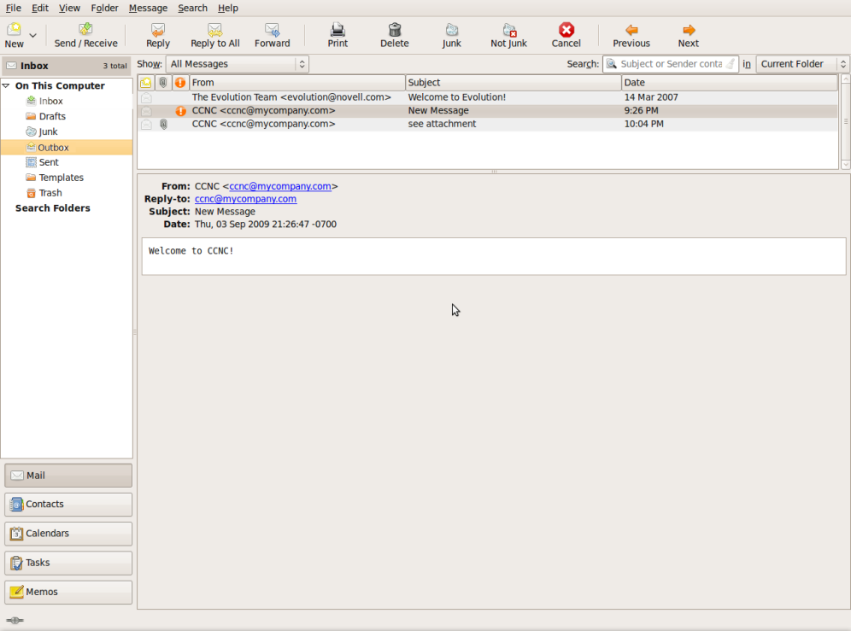

- To remove the high priority option, right click on the message and click Select as Unimportant.

Forward a Message

Forwarding a mail message involves sending a message you have received to one or more other recipients. You may edit the mail message and add your own message before you forward it.

The original message may be sent as an attachment or may be incorporated into the body of the e-mail.

Set the Forwarding Options

You can forward messages as an attachment, inline (as part of your message), or quoted.

- Choose EditPreferences from the Evolution menu and click Composer Options.
- Click the Forward style drop-list and select the style you wish.
- Click OK when done.

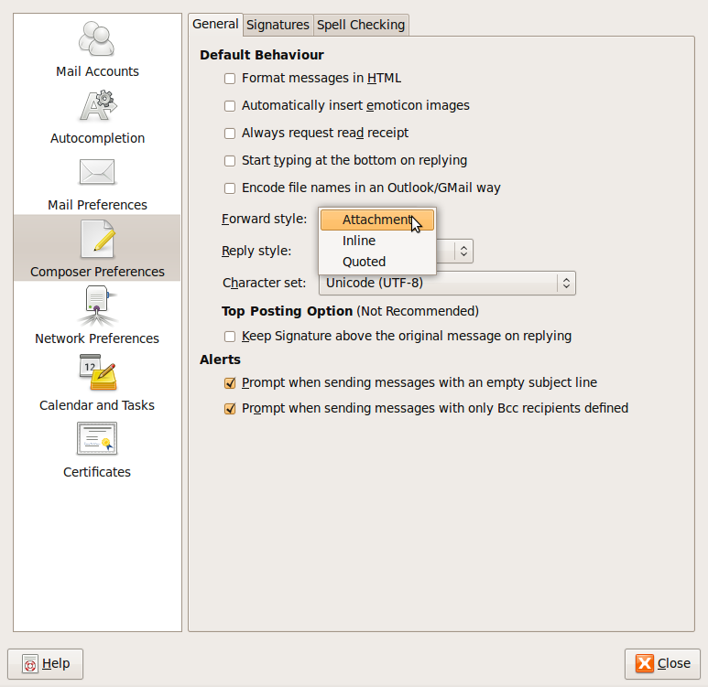

Forward an e-Mail
To forward an e-mail, open the mail message you wish to forward.
- Click the Forward button.
- Type in the list of e-mail addresses or a distribution list into the To window.
- Add/edit text in the same way you would if you were replying to a sender.
- Press Send when done.

Duplicate, Move and Delete Messages

Text can be copied or moved between messages in exactly the same way as is done between documents

Duplicate Text within an e-Mail Message

- Highlight the text to be duplicated.
- Choose EditCopy from the Evolution menu or press <Ctrl>C.
- Position the cursor where the text is to be inserted.
- Choose EditPaste from the Evolution menu or press <Ctrl>V.

Move Text within an e-Mail Message

- Highlight the text to be moved.
- Choose EditCut from the Evolution menu or press <Ctrl>-X.
- Position the cursor where the text is to be inserted.
- Choose EditPaste from the Evolution menu or press <Ctrl>-V.

Duplicate Text from Another Source into a Message

Suppose you have text in another e-mail message or in an OpenOffice.org Writer file that you wish to copy into an e-mail message.

- Open the document from which you wish to copy the text.
- Highlight the text and copy using EditCopy or press <Ctrl>-C.
- Switch to the message into which you wish to copy the text.

You can switch between any open document or message by clicking the icon displayed at the bottom of your screen.

- Choose EditPaste from the Evolution menu or press <Ctrl>-V.

Delete Text in a Message

- Highlight the text to be deleted and press the <Delete> key.

Delete a File Attachment from an Outgoing Message

Attachments to messages are shown in an attachment pane at the bottom of the screen.

- Right click on the attachment you wish to delete.
- Click Remove in the context menu.

Delete a Message

    - Click on the message you want to delete.
    - Press the <Delete> key on your keyboard. The message is deleted to your trash bin, and can be retrieved if necessary.

Empty the Mail Bin/Deleted Items Folder

If you are sure that you no longer need any message in Trash, you can empty its contents. This will permanently delete all the messages.

- Choose FileEmpty Trash from the Evolution menu.
- Click OK if you are sure.

Summary

This section brought you further into the practical use of Evolution
e-mail. We discussed opening messages, replying, and using file attachments. We also introduced the concept of managing messages by copying, deleting, and moving messages.

To assess your learning, make sure you are comfortable carrying out the following tasks in Evolution Mail:
- Open and read an e-mail message.
- Save and open an attachment to an e-mail message.
- Reply to a message.
- Attach a file to an e-mail message.
- Manage your messages by moving, copying, or deleting them.

Mail Management

Section Overview

In the previous section, we introduced you to e-mail management with deleting, copying, and moving messages. This section will help you to develop strategies for managing your e-mail – an important concept since your e-mail boxes are filled up quickly.
In this Section you will be introduced to some techniques to manage e-mail effectively such as creating and naming folders, moving messages to appropriate folders, deleting unnecessary e-mail, and using address lists.

Management Techniques
If you use e-mail as a regular feature of your daily work, it is quite possible that you will receive 50 or 100 e-mails in a day. Over a period of a few months, this adds up to thousands of e-mails. Obviously the frequent user will need to develop strategies not only for dealing with received mail, but also for sending mail.

Using Mail Folders

Mail folders are to e-mail what directories are to files. You can create mail folders in which you store incoming and outgoing mail.

Often users are careful about creating folders for incoming mail but forget completely about organising outgoing mail.

Copies of outgoing mail are allowed to accumulate in the Sent folder. One way of dealing with this is to create a folder for a particular category and then create two sub-folders within this for incoming mail and copies of outgoing mail.

Sometimes you may receive so much mail for a particular category that it needs to be divided into sub-categories which in turn have in-coming and out-going sub-folders.

When you create folders give them meaningful names.

You can modify your folder structure on an on-going basis and drag mail from one folder to the next.

Delete Unwanted Mail

Only keep mail that you need to keep a record of. As a security measure against viruses you may want to delete mail from suspicious sources without opening it.

If you find you are receiving spam, consider making use of anti-spam software that will block spam from known sources.

Make Use of Address Book and Distribution Lists to Send e-Mails

Instead of having to type an address every time you want to send an e-mail, you can make use of an Address Book.

Your address book should store all of your frequently used email addresses, enabling you to select from a list instead of having to re-type the addresses each time you send an email. This is the fastest way to address a message, and more importantly ensures that you will never make a typing mistake and send your email to the wrong address.

Create an Address Book

Create your own Address Book by clicking on ToolsAddress Book.

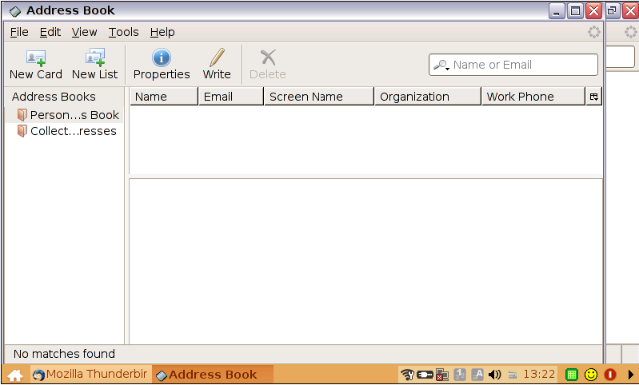

To enter a new address, click on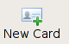 .

Complete the “card” as full as possible. It is good practice to keep a detailed address book. Ensure that there are no spelling errors/typos, especially in the e-mail address.

Hit OK when finished.

Update an Address Book from Incoming Mail

If possible, you should copy each address from a valid email and then paste it into your address book when you create an entry for the first time, because this is faster, and more importantly you will be sure there aren't any typing mistakes.

If the address form has an option like "Include on recipient or nickname list", then you should select that option to make sure the address will show up on your address book menu from anywhere in your email program.

Instead of typing a new entry into the Address Book, Evolution can do it for you directly from e-mail in your mail boxes:

- Right click on the message.
- Select Add to Address book in the context menu.
- A window will appear with the name and e-mail address of the new contact. Click Add to Address Book to add this to your existing address book.

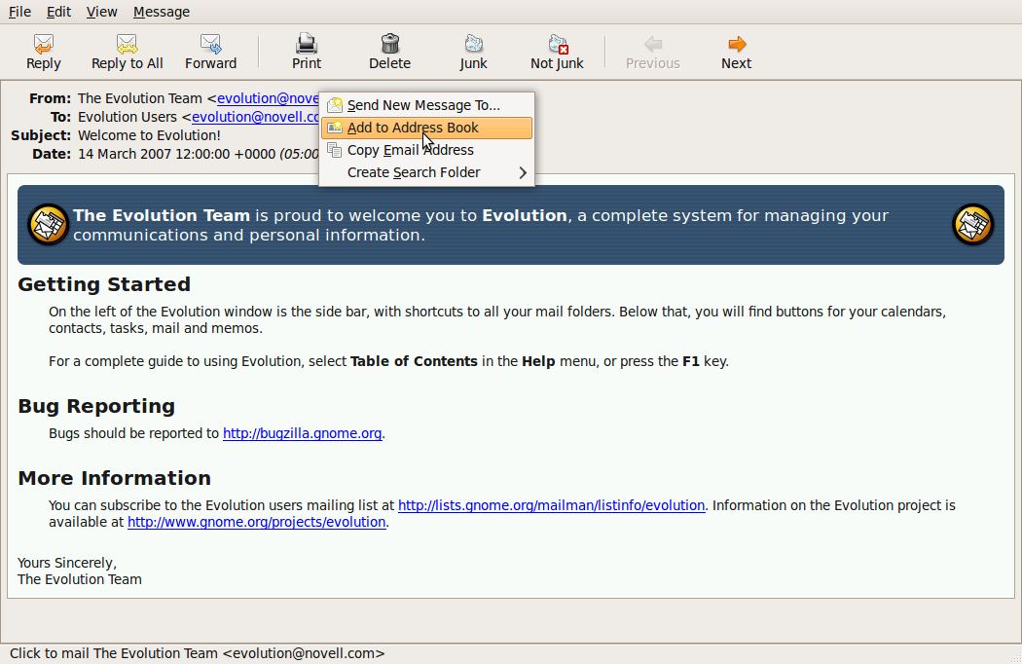

Distribution Lists

A Distribution List is used when you are frequently sending e-mails to a group of people.

A Distribution List is a list of e-mail addresses stored in your Address Book and you only need to enter the name of the distribution list when you want to send e-mails to all the people on the list.

Distribution lists provide a convenient way of sending the same e-mail to a number of users at the same time. By creating a number of distribution lists you can work very efficiently with Evolution.

Create a Distribution List

- Choose FileNewContact/Mailing list from the Evolution menu or go to your Address Book ToolsAddress Book and hit the New List button 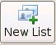.
- Enter a name for the new List.
- Type an e-mail address into the top window of the Members area.
- Click Add.
- Repeat this process to add new members.

- Click OK when complete.

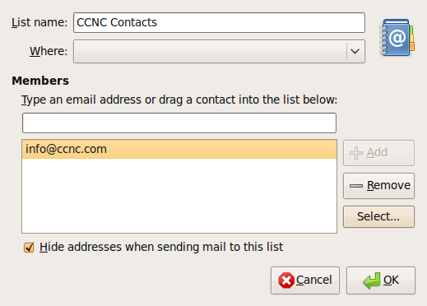

You can also get a screen like this one without an add button.

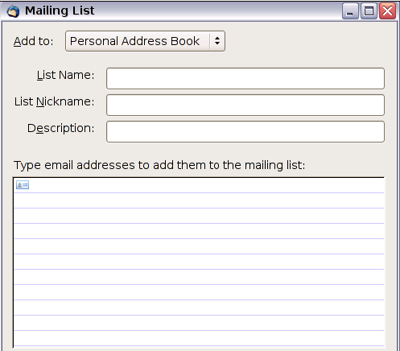

Send an e-mail to all Recipients on a Contact/Distribution List

To send an e-mail to a list, type the name of the Contact list into the To field instead of a normal e-mail address or select from your Address Book.
.
Note: You may click on the To icon to display a list of contacts and contact lists. You can then select the recipients (contact lists and contacts). Evolution will enter them automatically in the To field.

Search for Messages

You can enter filter criteria in the Search tool window that will enable you to display messages from a particular sender, messages having a similar subject title or messages containing certain words in the body of the message.

Type your search term in the search window and click on the Search button on the right side of the search window (the small broom icon).

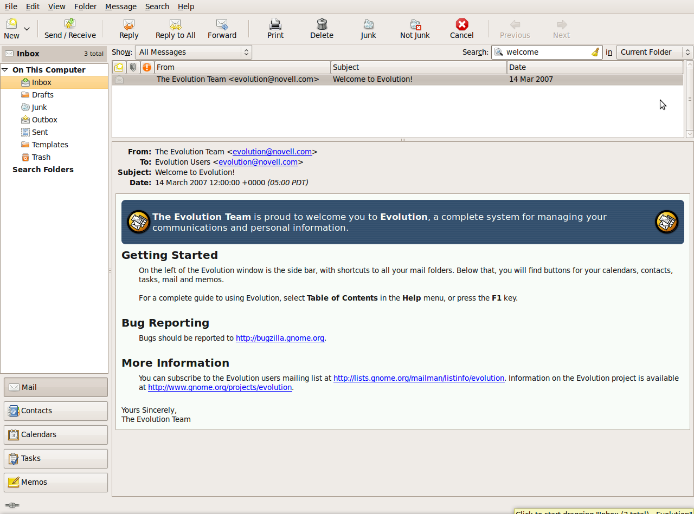

Search Criteria

You can search for messages by subject, sender, or recipient. Choose the search criteria from the drop-down list accessed by clicking on the magnifying glass icon on the left side of the search window. 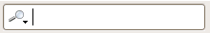
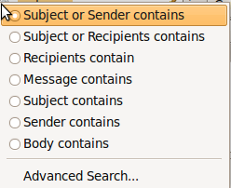

You can:

Search for messages by subject:
- Click Subject contains.
- Enter text that the subject must contain and click the Search button

Search for messages by sender:
- Click Sender contains.
- Enter text that selects the sender. (It can be part of the sender's name) and click the Search button.

Search for messages by body text:
- Click Body contains.
- Enter text that selects the sender. (It can be part of the sender's name) and click the Search button.

Search messages for content:
The previous three options limited the search to the sender, body text, or the subject. It’s also possible to search all parts of the message.
- Click Message contains.
- Enter a word or phrase that the message contains and click the Search icon.

Search using the other options:
The main components of a message are the sender, subject and message body. The body of a message is the actual text of the message excluding subject and sender. When you search using the Message contains option, the search function will scan the sender, subject and body. You can include just certain components of the message in the search. The main advantage is that by being more specific about where to search, the speed of the search will improve. This is important if you have thousands of messages in your mailbox.

Organising Messages

You can create folders and subfolders to organise your messages, in much the same way as you create a directory structure to organise your files.

Creating Folders

- Make sure the Folder bar is displayed.
- Choose FileNewMail Folder from the Evolution menu.

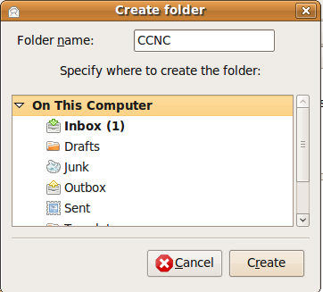

- Type in a name for the new folder.
- Click on On this Computer in the folder list.
- Click Create.

In the example above, a new folder called CCNC will be created at the same level as your Inbox, Drafts etc.

Create Sub-Folders

To create a subfolder within an existing folder:

- Choose FileNewMail Folder from the Evolution menu or click the New button on the tool bar and choose Mail Folder.
- Type in a name for the new sub-folder.

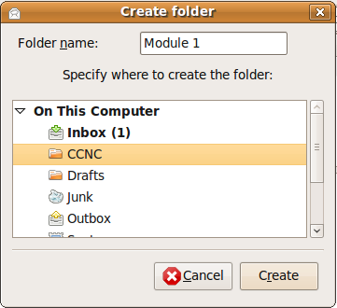

- Choose a folder to create the subfolder in (Specify where to create the folder:).

In the example above, a subfolder called Module 1 will be created in a folder CCNC.
- Click Create. The new folder will be created inside the folder you have selected.

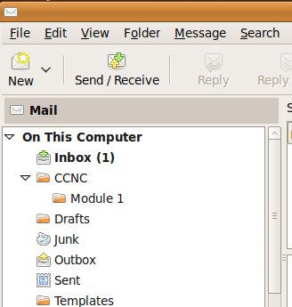

- Create any number of folders and sub-folders that suit your needs.

Move Messages to a New Folder

Move a message by dragging:

- Highlight the message you wish to move.
- Hold down the left mouse button and drag the message to the new folder.
- Release the left mouse button when the target folder is displayed with a solid border.

Move a message using the context menu:

- Right click on the message you wish to move.
- Select Move to Folder in the context menu.
- Highlight the target folder in the list that is displayed.
- Click OK.

Copy a Message to a New Folder

You can use a similar method to make a duplicate of a message in a folder.

- Right click on the message you wish to move.
- Select Copy to Folder in the context menu.
- Highlight the target folder in the list that is displayed.
- Click OK.

Prepare to Print

Messages can be printed just like any other document. In the interest of saving resources, only print messages if necessary. If you need a record of your e-mail, consider backing it up to an electronic storage medium instead.

Preview a Message

You can view what a message will like when printed before actually printing it:

- Click on the message you wish to preview
- Choose File Print Preview from the Evolution menu.

This will display the message as it will print.

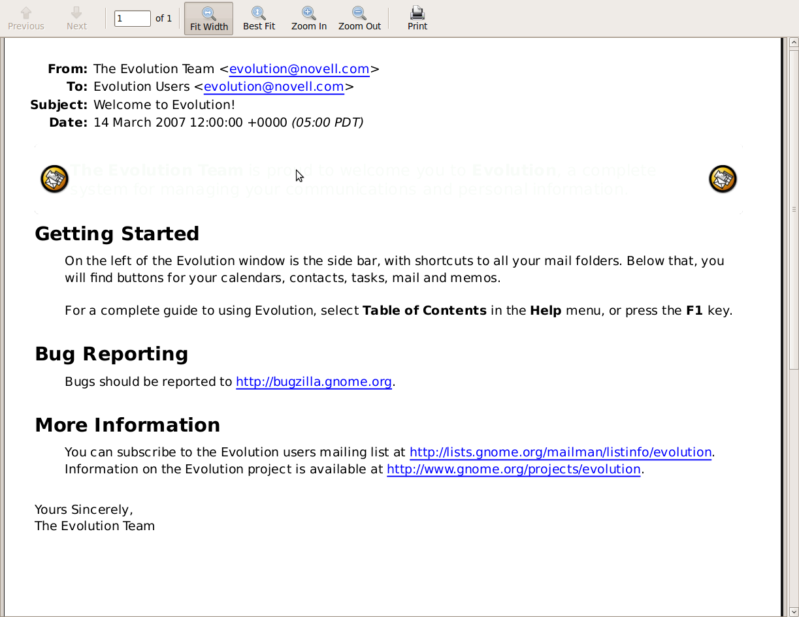

- If the message contains more than one page, you can move to the next or previous page. Alternatively you can move to the last page or the first page.
- You may also magnify or reduce the image.
- Click Print if you would like to print the message.

Choose Print Output Options such as: Entire Message, Selected Contents of a Message, Number of Copies and Print

- Open the message you wish to print.
- Choose FilePrint from the Evolution menu.

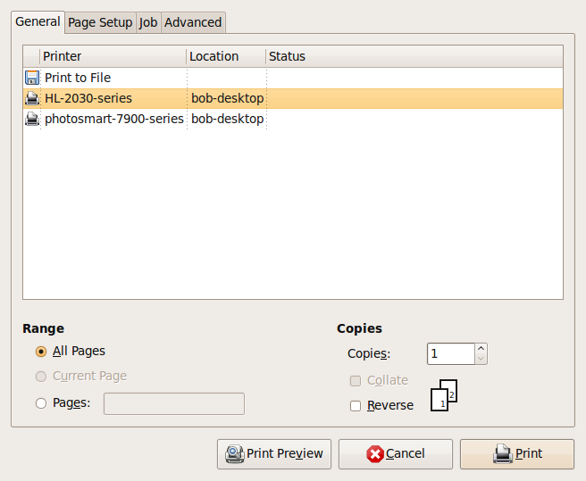

- Set the number of copies you wish to print.
- If the message contains more than one page, check Collate if you wish the pages to be collated.
- Specify a range of pages to be printed. By default, all pages are printed.
- Select the printer you wish to print to.
- Click on the Print button.

Web-Based e-Mail

There is a huge increase in the use of web-based e-mails. It is important that you are able to set up a web-based e-mail account for yourself. It has advantages and disadvantages as discussed.

You can make use of any Web-based e-mail. Some of them are free. For the purpose of these materials, Gmail is used.

What is GMail?

GMail is a web-based e-mail (webmail) platform (tool) where you can communicate messages electronically via the Internet. You can send just about anything instantly (Letters, documents, photos and files) to one or more people!

Some Advantages of using Gmail (and other web-based e-mail)

- it is free
- it is always available (provided you have internet access)
- it has great spam filters
- built-in chat: text, voice, or video (great for meetings)
- it allows you access to other good online tools:
  - Picasa (online photo album sharing)
  - Google docs (Free online office suite)
  - Blogger (free online blogging tool)
  - Google reader (Keep up to date)
  - Gtalk (an instant messenger service)
- you can
  - log into numerous sites using your Gmail address and password (great for privacy)
  - easily access it using your cell phone
  - organise your e-mail in numerous ways
  - separate your work and private e-mail
  - forward your Gmail to your private/work e-mail
  - set it up to download into Outlook for offline reading
- you get lots of space

Registering for a Gmail Account

You have been introduced to the Gmail registration form on page 56.

To register:

- Make sure that you are connected to the Internet
- Open up your browser (eg Firefox)
- Type in www.gmail.com into your browser address bar

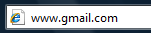

As you are a new user, click on Sign up for Gmail. In order to sign up for Gmail, you will first have to create a Google account.

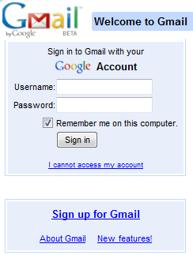

- Fill in your name and your surname
- Choose a username (try to find something that will not already be taken!)
- Hit Check availability…..
Choose new usernames untill you get one that is available!

- Type in a password (one that you will remember!). It must consist of at least 6 characters (use numbers and letters)
- Retype password

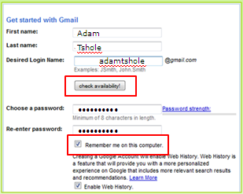

If you are using a public, school or work computer used by others, un-tick Remember me on this computer.

- Click on the drop-down arrow next to Security question
- Choose Write my own question
- Type in a simple question and answer
- If you have another e-mail (eg work), insert it otherwise, leave blank
- Click on the dropdown next to location and choose
your country.
- Type in the verification code very carefully.
- Accept the terms.

You will see that your Gmail has the same features as an ordinary e-mail account. Look for the equivalent action on the screen, for example Compose Mail means the same as hitting the New button.

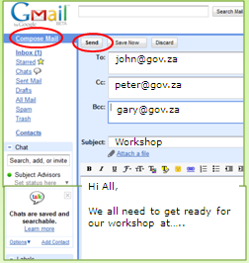

Familiarise yourself with the functionalities of the tool. You can now:

- Send and receive mail
- Attach documents
- Read and reply to messages
- Forward messages
- Compile an Address Book and Distribution Lists
- Manage your mail boxes
- Print e-mail and attachments

Summary

This section introduced you to some strategies for managing your e-mail messages, including using folders to store messages and using contact lists for distributing mail to multiple contacts.

You also learned some techniques for searching your e-mail messages for particular messages using a variety of search criteria. Finally, you learned how to set up your messages for printing.

To assess your learning, make sure you are comfortable carrying out the following tasks in Evolution Mail:
- Create folders, delete folders, and move folders in the Folder list.
- Move messages from the Message list to appropriate folders in the Folder list.
- Create a Contact list for distributing e-mails to many people at the same time.
- Manage your Contact lists by adding or deleting contacts.
- Search for messages on a variety of criteria.
- Set print options and print messages

Web-based Communication Technologies

Section Overview

This section will provide a brief overview of some newer, exciting technologies that enhance our ability to communicate in a number of ways. These include such things as instant messaging, podcasts, and virtual communities.

In this section you will:

- be introduced to some web-based communication technologies
- understand instant messaging technology and its application
- understand how podcasts are used to make media available
- learn about Short Message Service technologies
- understand Really Simple Syndication (RSS)
- learn about Voice over Internet Protocol (VOIP) technologies
- be introduced to virtual communities/social networking such as FaceBook

Instant Messaging (IM)

Instant messaging (IM) is a form of real-time communication between two or more people based on typed text. The text is conveyed using devices connected over a network, usually over the Internet.

What separates IM from e-mail is that the communication is in real-time (or very close to that). Feedback, therefore, is immediate, and that promotes a sense that the communication is synchronous. Also, it’s usually possible to tell if contacts are online or not.

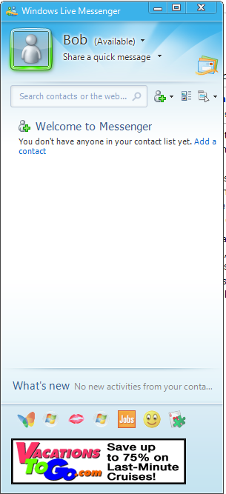
Instant messaging systems came before the Internet, but were limited to communication between users of the same local network. In the mid-1990s, modern IM applications began to arise, with some of the most popular being PowWow and ICQ.

Some systems also attempted to incorporate audio and video (using webcams) into an IM session, most notably CU-SeeMe and Microsoft NetMeeting. File transfer and application sharing were features of some IM applications as well.

At present, there are a variety of protocols used to specify communication with instant messaging. As a result, IM applications often do not work with other IM applications, or sometimes even with a different version of the same application. For best results it’s important to use the same version of the same application.

Most IM applications are freely downloadable, making instant messaging a low cost solution for real-time communication over the Internet.
The most popular IM applications, at least in the western world, are Windows Live Messenger and Yahoo! Messenger. An application called Tencent QQ, with a massive user base in China, eclipses both of these however.

Podcasts

A podcast is a series of audio or video files that are released as episodes. It is this episodic nature that differentiates podcasts from other media downloads. To support this, you must go through a process to subscribe to the podcast service.

Podcasts take advantage of software that can automatically identify and download new “episodes” as they are released. Many popular media player applications double as “podcatchers”, including iTunes, Zune, or Winamp.

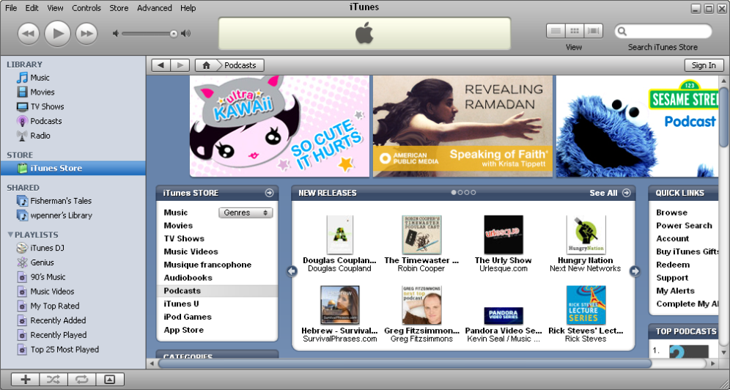

Short Message Service (SMS)

Short Message Service (SMS) is commonly known as text messaging or “texting”. It is a standardised service, which means that it uses a set of standard communication protocols that allow various devices to communicate with each other.

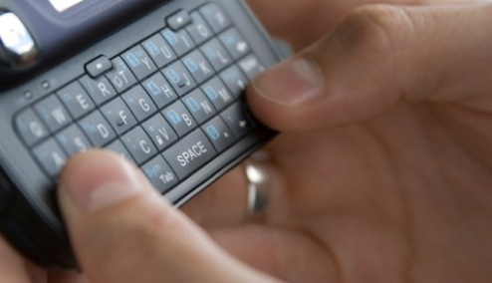

SMS is the most widely used data application on the planet, with over 2.4 billion users (over 74% of mobile phone subscribers). In 2006, the SMS industry was worth over 81 billion dollars annually.

Really Simple Syndication (RSS)

RSS or RSS Feeds, are web feeds used to publish content that is frequently updated, such as news headlines, stock market quotations, audio, or video. They benefit users who need to get timely updates to variable content.

RSS formats are specified using XML (extensible markup language), a standard specification for the creation of data formats.

Below is an image of the Canadian Broadcasting Corporation’s headline news RSS feed.

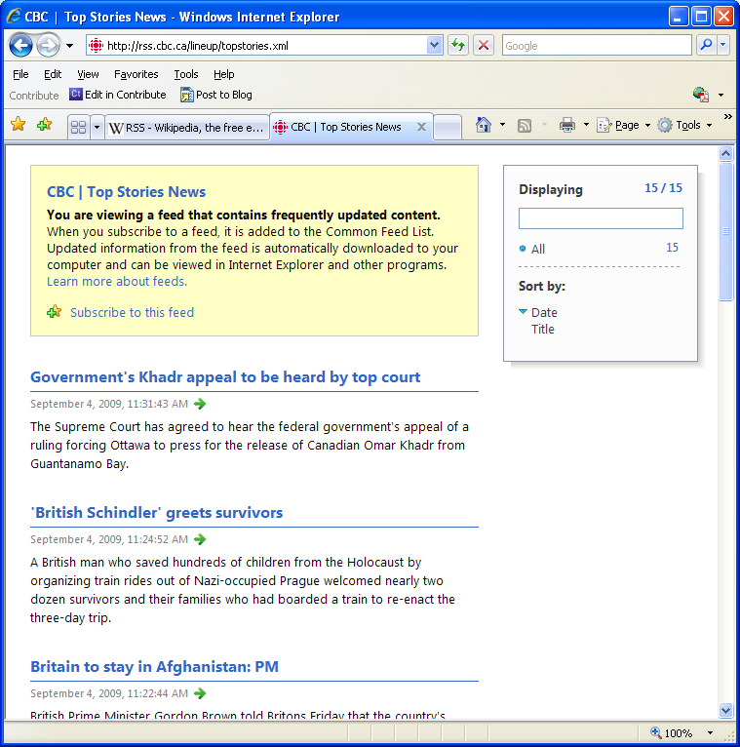

Voice Over Internet Protocol (VoIP)
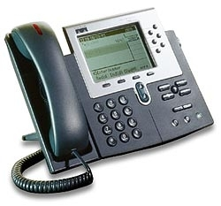
Voice Over Internet Protocol (VoIP) is a group of technologies that deliver voice communication over Internet networks, essentially bypassing the traditional public switched telephone networks.

The protocol specifies the conversion of the analog voice signal to digital, the translation of the digital signal to Internet Protocol for transfer over the Internet, and the reverse process at the other end of the call.

VoIP can be a great benefit for reducing communication costs, since there is no need for separate data and voice lines. Also, costs are lower since traditional phone lines are billed by the minute, but VoIP calls are billed by the volume of data transferred (in megabytes). In practice, the amount charged for a 1-hour VoIP call is much less than for a 1-hour call on a regular telephone line.

Virtual Communities

Virtual communities have been around for longer than the Internet. It began with electronic bulletin board systems (BBS) which were connected to using a modem and analog telephone lines. These communities were formed by people interested in similar subjects, like computing for example.

The original Internet virtual communities, formed primarily on USENET, were heavily text based. On the other hand, modern virtual communities use Web applications that incorporate a great variety of media and interactive capability such as synchronous text, audio, and video communication.

The social networking applications such as FaceBook and MySpace, are examples of the latest generation of virtual communities.

Virtual communities come with some philosophical issues, particularly centred around what influence the virtual community has on the physical community of an individual, especially with children who are developing their ability to communicate and relate in the “real” world. As well, issues of privacy abound, since many of these communities are not entirely away from the public eye.

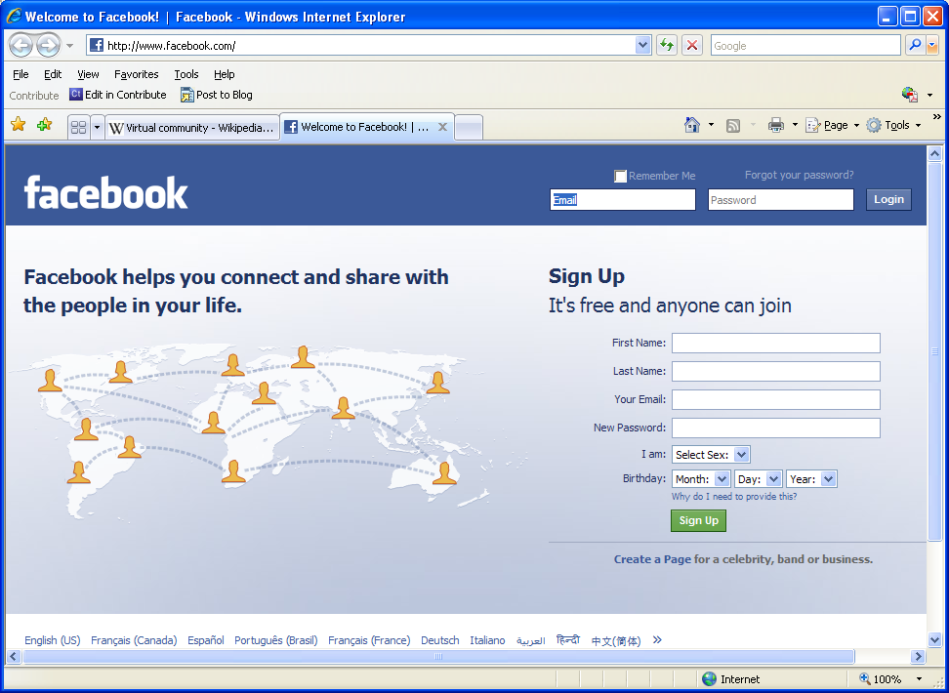

Summary

This section introduced the concept of web-based communication technologies. These technologies are evolving rapidly. They offer many benefits to their user groups: the ability to communicate with large groups of people, in real-time, with text, audio, and video, and for a relatively low cost. However, they also are clearly affecting the way we interact as a society, and their social impact on our culture is just beginning to be seen.

